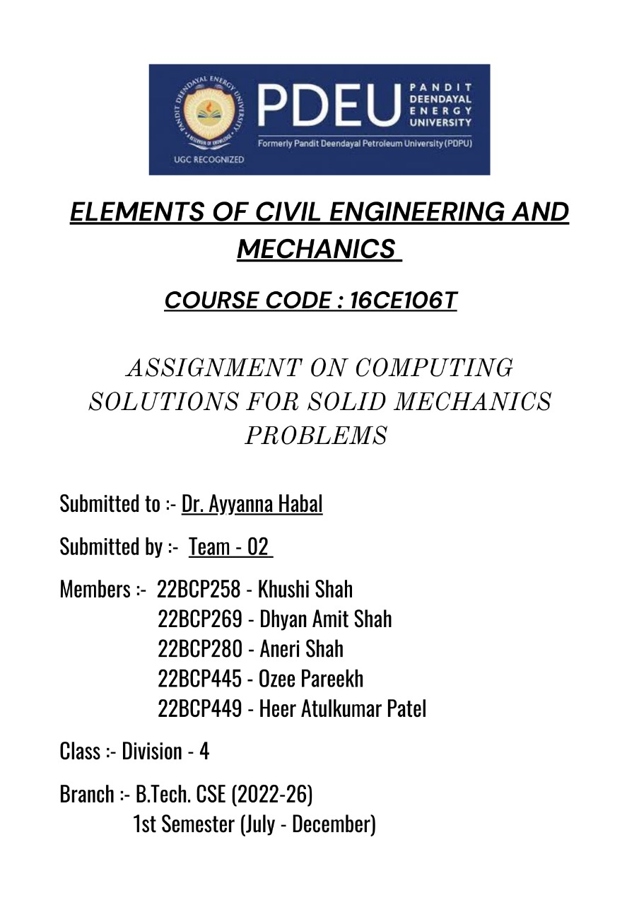

# C++ code for calculating MOI & COG of COMPOUND FIGURES

# INDEX

|  |  |  |
| --- | --- | --- |
| Sr. No. | CONTENT | Page Number |
| **1** | **INTRODUCTION** | **1 - 16** |
| **2** | **WORKING OF THE CODE** | **16-21** |
| **3** | **FLOW OF EXECUTION** | **22** |
| **4** | **OUTPUT** | **23-73** |
| **5** | **FUTURE SCOPE** | **74** |
| **6** | **BIBLIOGRAPHY** |  |
|  |  |  |

**MOMENT OF INERTIA**

**OF DIFFERENT SHAPES AND GEOMETRY**

|  |  |
| --- | --- |
|  | Moment of inertia is defined as the quantity expressed by the body resisting angular acceleration which is the sum of the product of the mass of every particle with its square of a distance from the axis of rotation. Or in more simple terms, it can be described as a quantity that decides the amount of torque needed for a specific angular acceleration in a rotational axis. Moment of Inertia is also known as the angular mass or rotational inertia. The SI unit of moment of inertia is kg m2.  n General form Moment of Inertia is expressed as  I = m × r2 where,  m = Sum of the product of the mass.  r = Distance from the axis of the rotation.  and, Integral form:  I = ∫dI = ∫0M r2 dm ⇒ The Dimensional formula of the moment of inertia is given by,  M1 L^2 T^0  The role of the moment of inertia is the same as the role of mass in linear motion. It is the measurement of the resistance of a body to a change in its rotational motion. It is constant for a particular rigid frame and a specific axis of rotation.  Moment of inertia,   I = ∑mi ri2 *Factors affecting MOI* The moment of inertia depends on the following factors,   * The density of the material * Shape and size of the body * Axis of rotation (distribution of mass relative to the axis)   We can further categorize rotating body systems as follows:   1. Discrete (System of particles) 2. Continuous (Rigid body)   **MOI FOR TRIANGLE**  Moment of inertia of a triangle can be expressed in various ways. There are usually three moments that can be considered. They are;   * Axis passing through the centroid. * Axis passing through the base. * The axis perpendicular to its base.   We will look at each expression below.  ***1. Axis passing through the centroid***  The moment of inertia of a triangle having its axis passing through the centroid and parallel to its base is expressed as;  I = bh3 / 36  Here, b = base width and h = height  ***2. Axis passing through the base***  If we take the axis that passes through the base, the moment of inertia of a triangle is given as;  I = bh3 / 12    We can further use the [parallel axis theorem](https://byjus.com/physics/parallel-perpendicular-axes-theorem/) to prove the expression where the triangle centroid is located or found at a distance equal to h/3 from the base.  ***3. The axis perpendicular to its base***  When we want to determine the moment of inertia of a triangle when its axis is perpendicular to its base we have to first consider that axis y’-y’ is used in dividing the whole triangle into two right triangles respectively A and B. However, these triangles will have a common base equal to h, and heights b1 and b2. The moment of inertia for both will be:  Iy’ = hb13 / 12 + hb23 / 12  If we consider b2 = b – b1 where the parallel axis y-y through the centroid is at a distance ⅔ ( b / 2 – b1) from y’-y’ then we can easily find or calculate the moment of inertia ly. We can use the parallel axis theorem to do so. In any case, after algebraic substitutions, we get the expression as:  Iy’ = ( hb / 36 )( b2 – b1b + b12 )  Moment Of Inertia Of A Triangle  **MOI OF SQUARE**  The moment of inertia of a square is given by the formula.  I = a4 / 12  Here, a = sides of the square section. This equation is for a solid square where its centre of mass is along the x-axis.  The diagonal [moment of inertia](https://byjus.com/jee/moment-of-inertia/) of a square can also be calculated as;  Ix = Iy = a4 / 12    Moment Of Inertia Of A Square  Alternatively, if the centre of mass (cm) is moved to a certain distance (d) from the x-axis we will use a different expression for determining the moment of inertia of the same square.  I = a4 / 3  **MOI OF RECTANGLE**  Moment of inertia of a rectangle along with its formulas with respect to different situations is discussed here. There are generally three situations that we will discuss in this lesson. **1. An Axis Passing Through Its Centroid** When we take a situation when the axis passes through the centroid, the [moment of inertia](https://byjus.com/jee/moment-of-inertia/) of a rectangle is given as:  I = bh3 / 12  Here, b is used to denote the rectangle width (the dimension parallel to the axis) and h is said to be the height (dimension perpendicular to the axis). **2. An Axis Passing Through Its Base** If we talk about an axis passing through the base, the moment of inertia of a rectangle is expressed as:  I = bh3 / 3  This can be easily determined by the application of the Parallel Axis Theorem since we can consider that the rectangle centroid is located at a distance equal to h/2 from the base. Parallel Axis Theorem If we take the parallel axis theorem it can be used in determining the [area moment of inertia](https://byjus.com/jee/area-moment-of-inertia/) of any shape that is present in any parallel axis. Here, we can find the non-centroidal axis if we know its moment of inertia with respect to a centroidal axis that is parallel to the first one. Usually, the equation is given as;  I = Ix + AD2  Ix = moment of inertia in arbitrary axis  A = area of the shape  D = the perpendicular distance between the x and x’ axes. **3. A Centroidal Axis Perpendicular To Its Base** When we take the centroidal axis perpendicular to its base, the moment of inertia of a rectangle can be determined by alternating the dimensions b and h, from the first equation that is given above. We will get the following equation;  Iy = hb3 / 12 |
|  |  |

**MOI OF CIRCLE**

Moment of inertia of a circle or the second-moment area of a circle is usually determined using the following expression;

I = πR4 /4

Here, R is the radius and the axis is passing through the centre. This equation is equivalent to

I = π D4 / 64

when we express it taking the diameter (D) of the circle.

Similarly, a circle’s moment of inertia about an axis tangent to the circumference is given by;

I = 5πR4 / 4

The polar moment of inertia of a circle is expressed as;

I = 5πR4 / 2

## SEMI-CIRCLE

## For a semi-circle the formula is given as:

I = πR4 /8

MOI OF TRAPEZOID

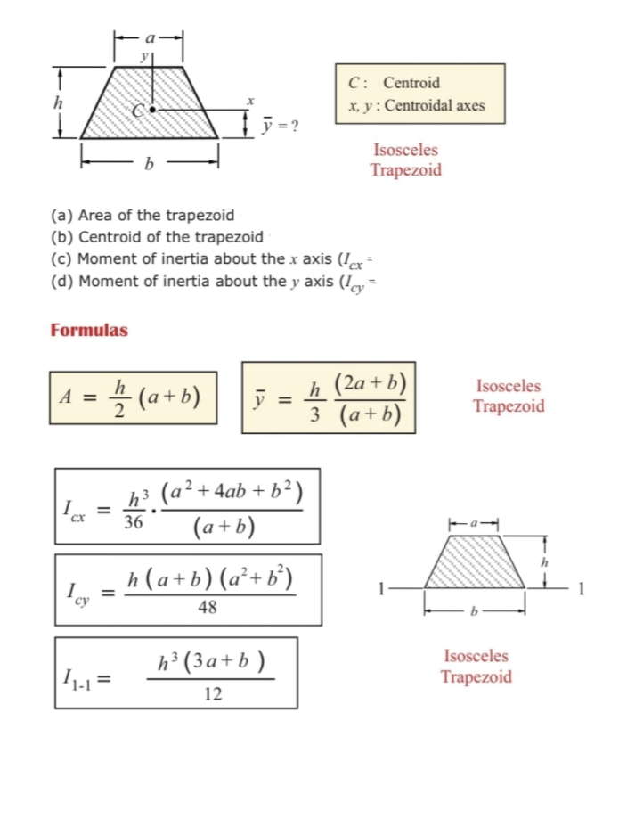

**Parallel Axis Theorem**

Parallel axis theorem statement can be expressed as follows:

I = Ic + MS2

Where,

* I is the moment of inertia of the body
* Ic is the moment of inertia about the center
* M is the mass of the body
* S2 is the square of the distance between the two axes

## **Perpendicular Axis Theorem**

The perpendicular axis theorem states that

*For any plane body, the moment of inertia about any of its axes which are perpendicular to the plane is equal to the sum of the moment of inertia about any two perpendicular axes in the plane of the body which intersect the first axis in the plane*.

Perpendicular axis theorem is used when the body is symmetric in shape about two out of the three axes. If the moment of inertia about two of the axes are known the moment of inertia about the third axis can be found using the expression:

I z = Ix + Iy

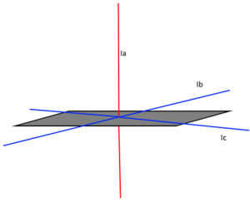

Say in an engineering application, we have to find the moment of inertia of a body, but the body is irregularly shaped, and the moment of in these cases, we can make use of the parallel axis theorem to get the moment of inertia at any point as long as we know the [centre of gravity](https://byjus.com/physics/difference-between-centre-of-gravity-and-centroid/) of the body. This is a very useful theorem in space physics, where the calculation of the moment of inertia of spacecraft and satellites makes it possible for us to reach the outer planets and even the deep space. The theorem of the perpendicular axis helps in applications where we don’t have access to one axis of a body, and it is vital for us to calculate the moment of inertia of the body in that axis.

**RADIUS OF GYRATION**

We can define the radius of gyration as the imaginary distance from the centroid at which the area of cross-section is imagined to be focused at a point in order to obtain the same moment of inertia. It is denoted by k.

### ***Radius of Gyration Formula***

**The formula of moment inertia in terms of the radius of gyration is given as follows:**

I*=*mk*2* (1)

where I is the moment of inertia and m is the mass of the body

**IMPORTANCE OF MOI**

The moment of inertia (MOI) is one of the many mass properties that describe an object’s stability and the forces needed to alter its motion. For aerospace engineering, **stability is a crucial element** in designing and manufacturing air and spacecraft. Knowing the MOI about various axes is vital to determining how a device can hold up to external and internal forces. Accuracy in measuring this value will ensure a better-produced craft or equipment to meet the specific needs of various projects in the stringent air and space industry.





## **What is C++?**

## C++ is a cross-platform language that can be used to create high-performance applications. C++ was developed by Bjarne Stroustrup, as an extension to the [C language](https://www.w3schools.com/c/index.php). C++ gives programmers a high level of control over system resources and memory. The language was updated 4 major times in 2011, 2014, 2017, and 2020 to C++11, C++14, C++17, C++20.

**Why Use C++**

C++ is one of the world's most popular programming languages. C++ can be found in today's operating systems, Graphical User Interfaces, and embedded systems. C++ is an object-oriented programming language which gives a clear structure to programs and allows code to be reused, lowering development costs. C++ is portable and can be used to develop applications that can be adapted to multiple platforms.

C++ is fun and easy to learn!

As C++ is close to [C](https://www.w3schools.com/c/index.php), [C#](https://www.w3schools.com/cs/index.php) and [Java](https://www.w3schools.com/java/default.asp), it makes it easy for programmers to switch to C++ or vice versa.

**Note:-**

1. To run the following program , one must have a C++ compiler on their device . Turbo C++\ Visual studio code platforms can be used for the same.
2. The following interactive program is useful to find the centroid , and moment of inertia of given compound figures with respect to centroidal or base axes as per user’s wish.

**SALIENT FEATURES:**



* The code gives centroid, moment of inertia and centre of gravity along base axes and centroidal axes of complex shapes.
* It prints proper figures and its dimensions as inputted by user.
* It can be used as calculator which can be used even in real life.
* It gives outputs for I section, hollow square , hollow square in triangle, trapezoid and hollow circle in circle.

**Working of the code**

* The first 3 lines of the code imports few libraries that are to be used in the program. Then after structures, there are a set of values stored in one variable which are defined to store data of shapes.
* The function nm is called for user to choose the shape. Code further runs as per the choice.
* Line 36-214 is a function MoI2 which calculates the centroid and moment of inertia of the given figure if selected for 3.

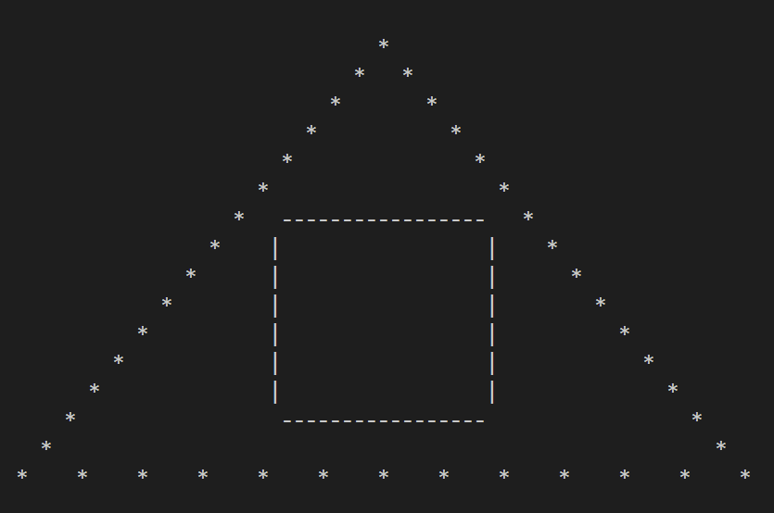

Herein the user has to input the measurements of base, height of triangle as well as the length of the side of square enclosed. Now the program calculates the centroid of square (j1,k1) and of the triangle (j2,k2) using suitable formula. Then, (G,H) the centroid for the whole figure is found along with its moment of inertia along centroidal axis and radius of gyration (Z).

* Line 216-455 is a function Moi1 which will be used to calculate centroid and moment of inertia of the given figure.

The user is asked to input the length and breadth of the 2 identical and one middle rectangle. Then the centroid of lower rectangle(x1,y1), middle rectangle(x2,y2) and the upper rectangle (x3,y3) is calculated along with their respective areas (A1,A2,A3). The moment of inertia is found out and stored in Mp (Mx=Ixx,My=Iyy).The user is given choice to view either Ixx or Iyy and the radius of gyration is printed

**Step 1: The beam sections should be segmented into parts**

The I beam section should be divided into smaller sections. The moment of inertia must be calculated for the smaller segments. Here, the section is divided into three rectangular segments.

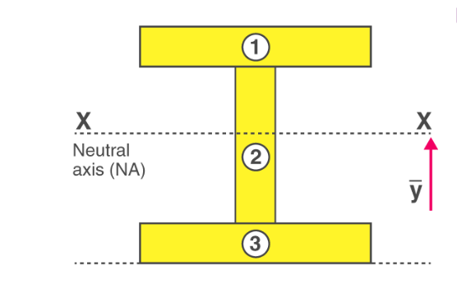

**Step 2: Mark the neutral axis**

The neutral axis is the horizontal line passing through the centre of mass. The centre of mass is calculated using the following formula

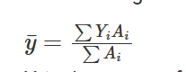

Yiis the centre of mass of the individual rectangle

Aiis the area of the individual rectangle

**Step 3: Calculating the Moment of Inertia**

Using the parallel axis theorem the total momentum is calculated as

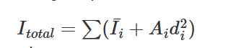

(Ii) is the inertia of the individual segment about its own centroid axis.

Aiis the individual segment.

di is the vertical distance from the centroid of the segment.

The moment of inertia of each of the rectangular parts must be calculated. The moment of inertia equation of a rectangle about its centroid axis is

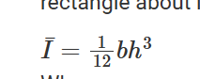

where,

b is the base of the rectangle.

h is the height of the rectangle.

Line 456-643

The function Moi will be used to calculate the centroid and moment of inertia of the given figure.

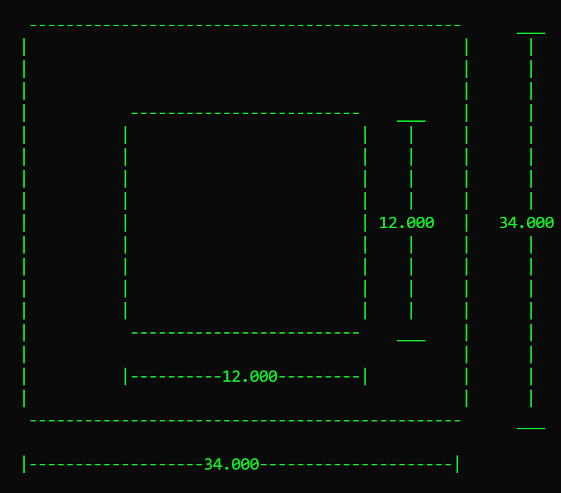

The user is asked to input the length of outer square and inner, smaller square. Their centroid (X1,Y1) is calculated. Using all other values , the final centroid (P,Q) of the whole figure is calculated. The user is then asked to choose between moment of inertia about x or y base axis (Iox,Ioy) or centroidal axis (Ixx,Iyy).The radius of gyration is then printed on output screen.

**Calculation:**

Moment of inertia of hollow section can be found by first calculating the inertia of larger rectangle and then by subtracting the hollow portion from that large rectangle.

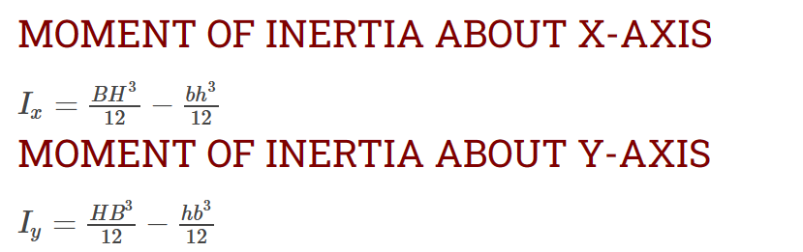

* Line 645-799 is a Function Moi3 is used to find the centroid and moment of inertia of hollow circle with respect to axis selected.

Let us consider one hollow circular section, where we can see that D is the diameter of main section and d is the diameter of cut-out section as displayed in following figure. O is the centre of the circular section as displayed in following figure.

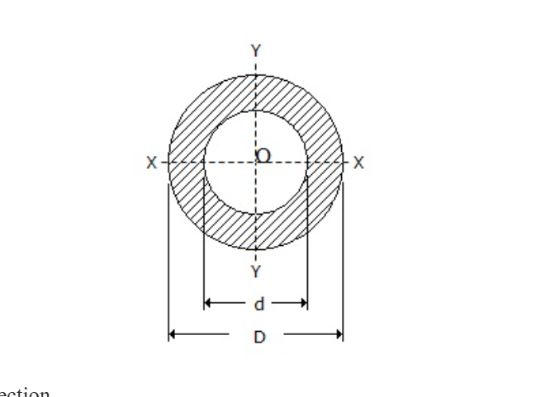

Now we will determine the value or expression for the moment of inertia of hollow circular section about XX axis and also about YY axis

As we have already seen the basic principle of [moment of inertia for the circular section](https://www.hkdivedi.com/2017/02/moment-of-inertia-of-circular-section.html) and hence moment of inertia of the main circular section about XX axis and moment of inertia of the cut-out circular section about XX axis will be determined as mentioned here.

Moment of inertia of the main circular section about XX axis = ПD4/64

Moment of inertia of the cut-out circular section about XX axis = Пd4/64

Moment of inertia of hollow circular section about XX axis = [ПD4/64]-[Пd4/64]

IXX = П (D4-d4)/64

Similarly, Moment of inertia of hollow circular section about YY axis, IYY = П (D4-d4)/64

Therefore, we have concluded

***IXX = П (D4-d4)/64***

***IYY = П (D4-d4)/64***

* Line 645-799 is a function for trapezoid. Herein the user has to input the measurements of top , base and height of trapezoid. Now the program calculates the centroid of the trapezium () using suitable formula. Then its moment of inertia along centroidal axis and radius of gyration (Z) as well as along base axes is printed as per choice.

the moment of inertia Ix0 of the trapezoid, relative to axis x0, passing through the bottom base, is determined like this:

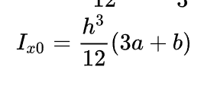

The moment of inertia relative to centroidal axis x-x, can be found by application of the Parallel Axes Theorem . The position of the centroid must be determined first though, and more specifically its vertical distance from the bottom base (in other words its y0 coordinate).

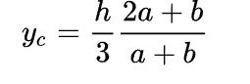

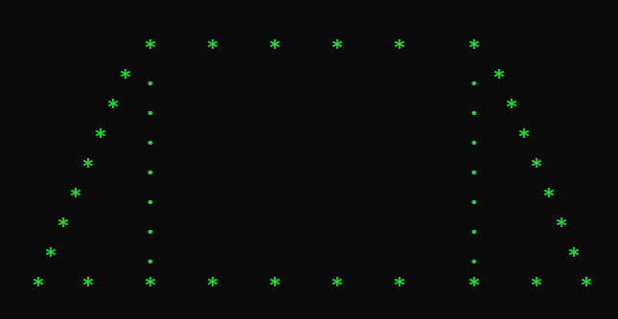

* Line 1012-1059 is the function mn, for user to choose to either exit the game or continue with another choice. If 1 is selected , the loop continue else 2 exits the code.

**Flow of Execution of Code**

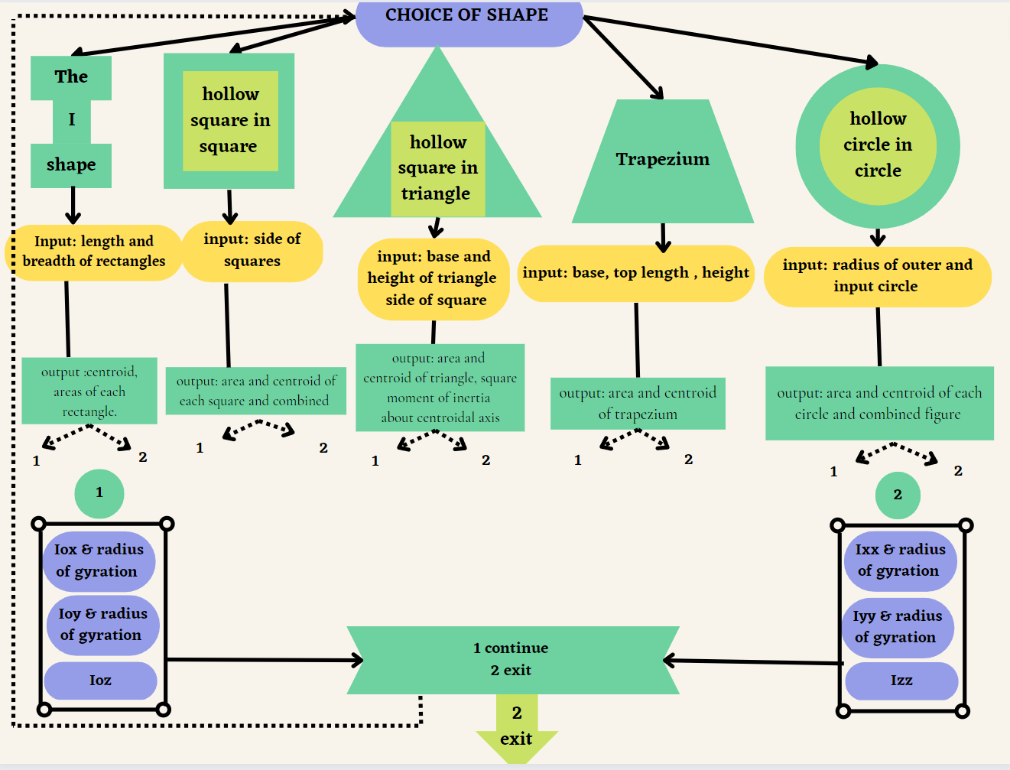



**OUTPUT**

For a uniform symmetrical I shaped section of beam of upper and lower rectangles of same dimensions, find out it’s centroid, moment of inertia along centroidal and base axes. Base length and height of base rectangles are 12mm, 10mm and of web rectangle are 30mm and 10mm.

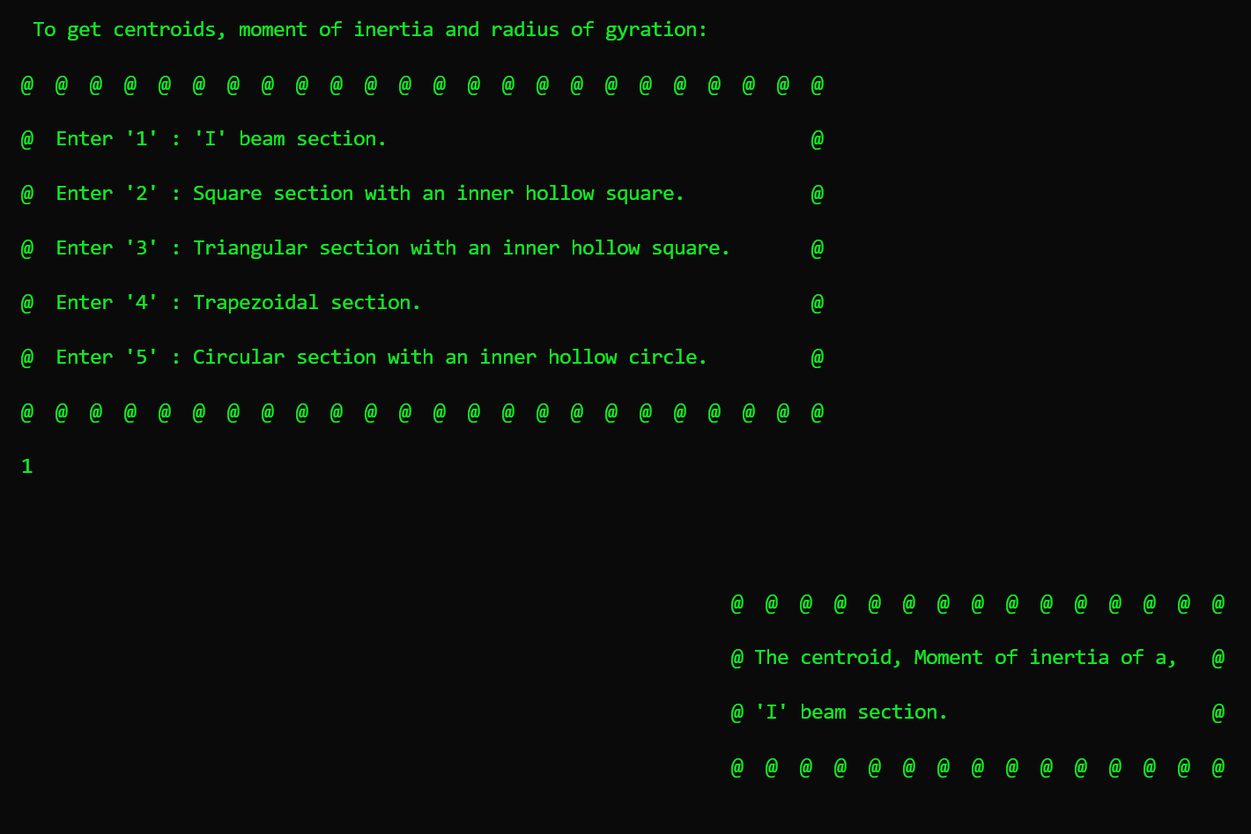

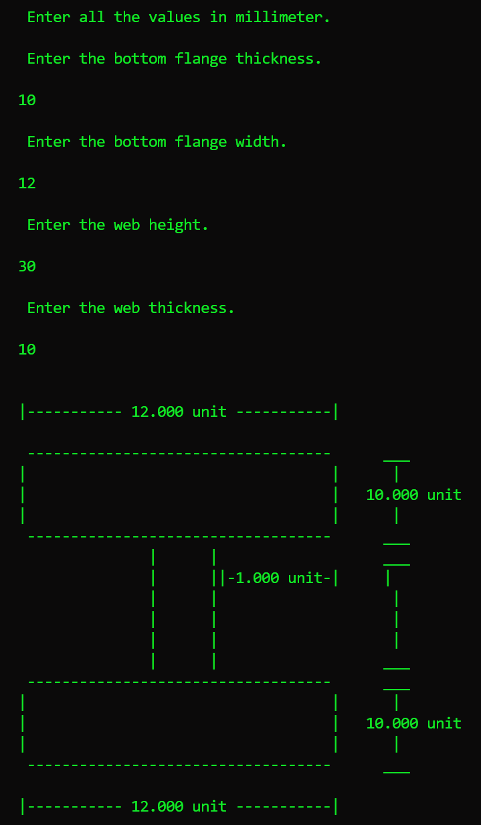

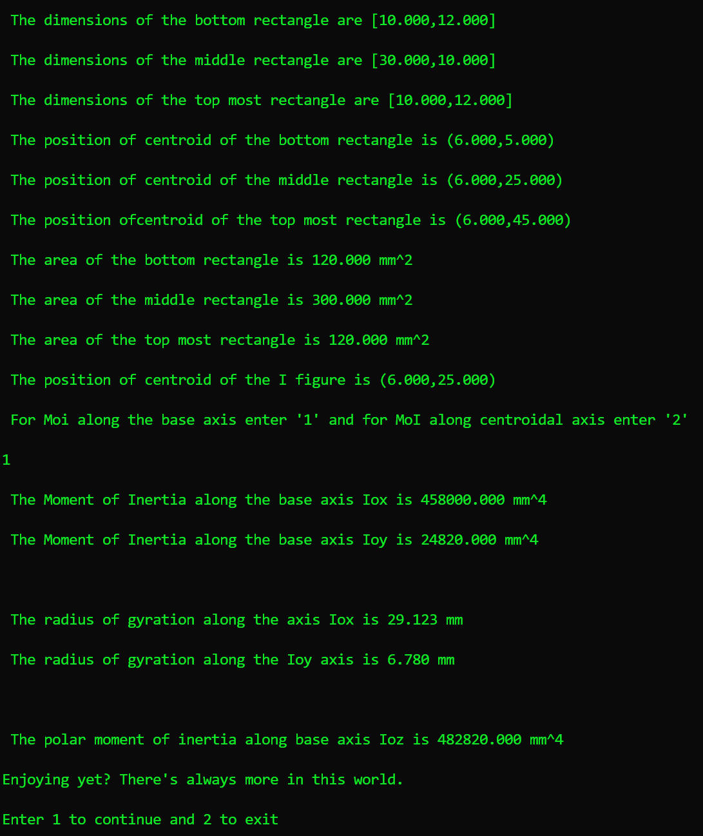

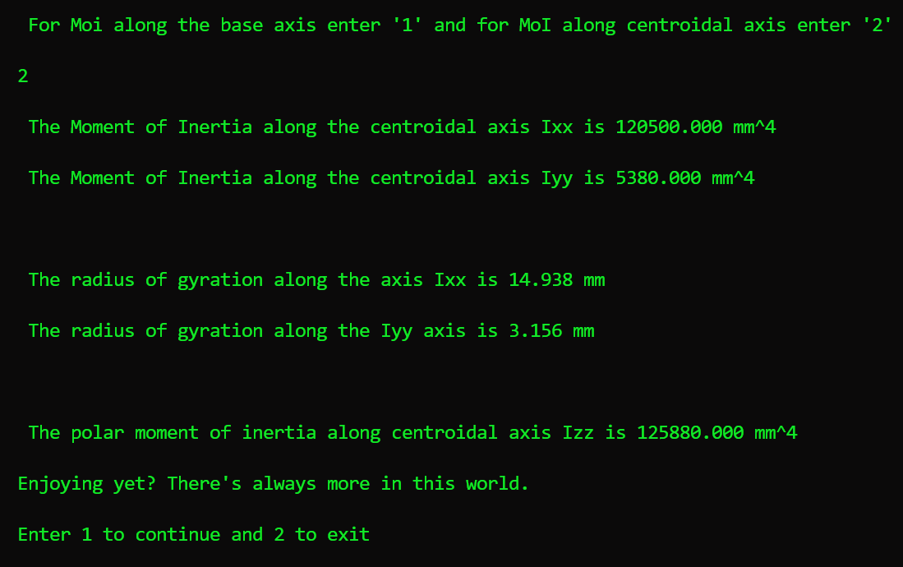

Find the centre of gravity and moment of Inertia along with radius of gyration of hollow square with square cavity. The side length of cavity is 80mm and outer square is 130mm.

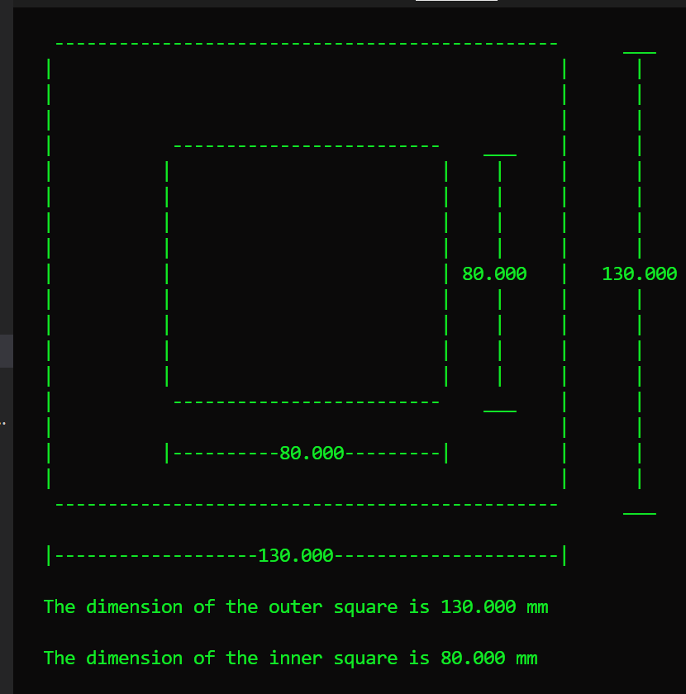

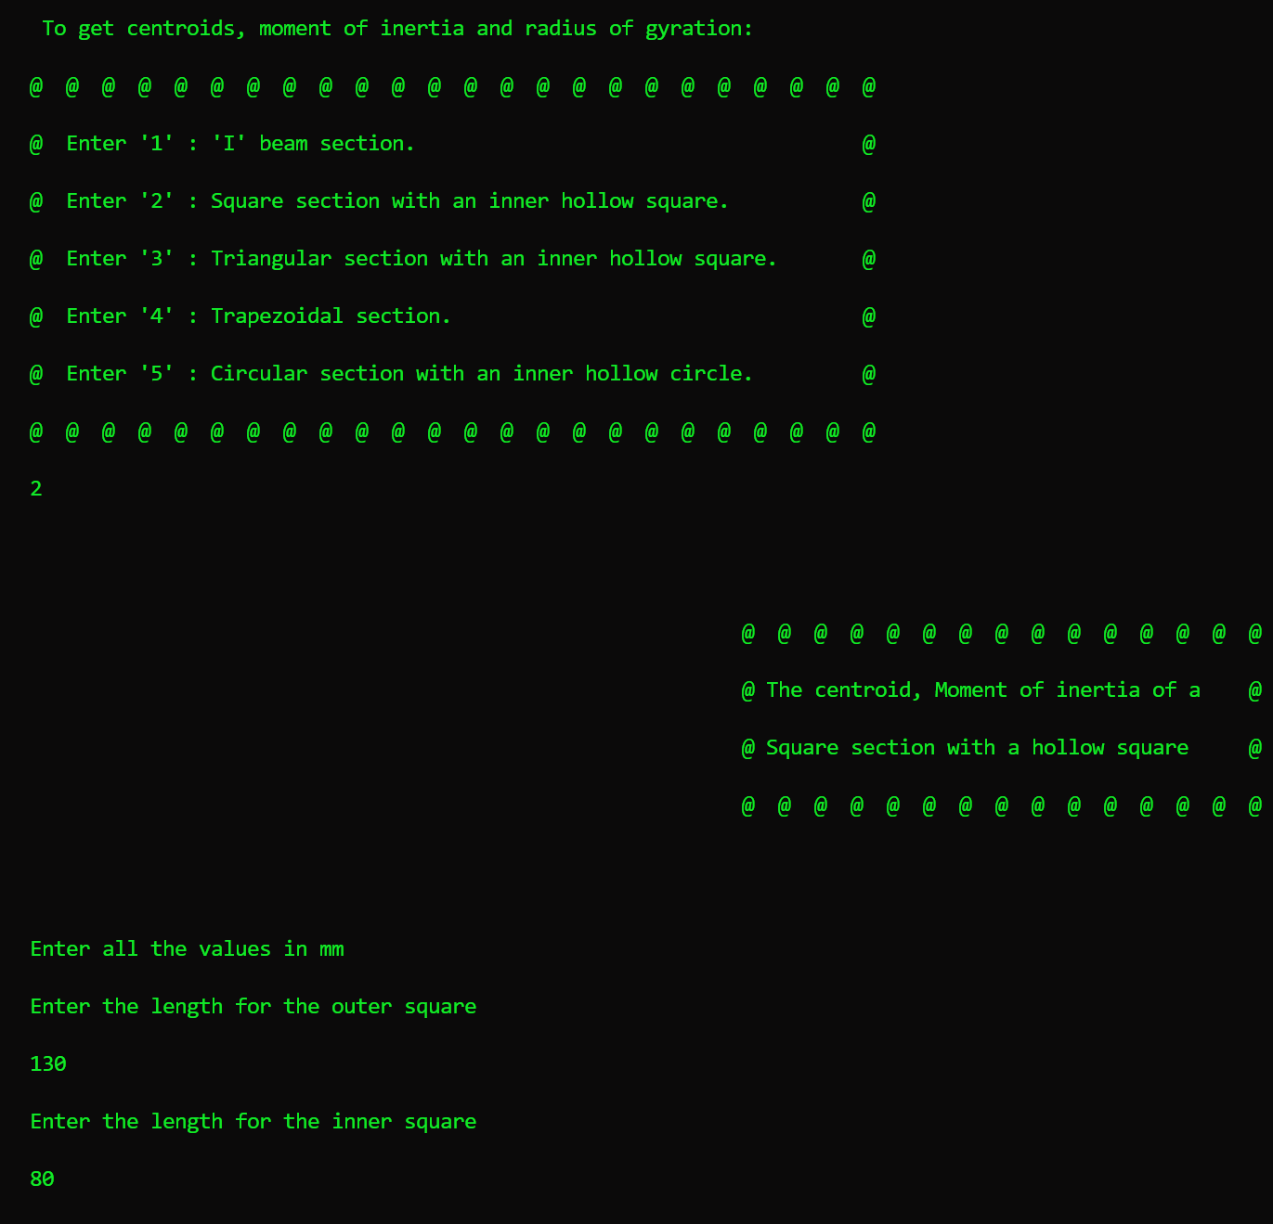

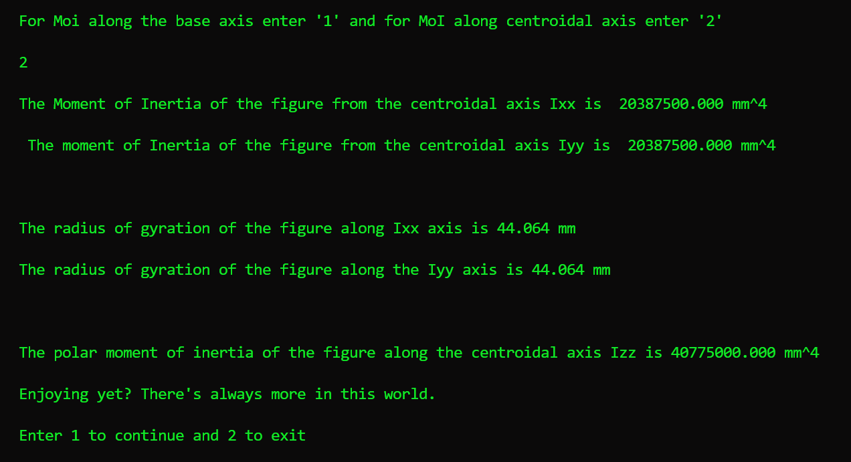

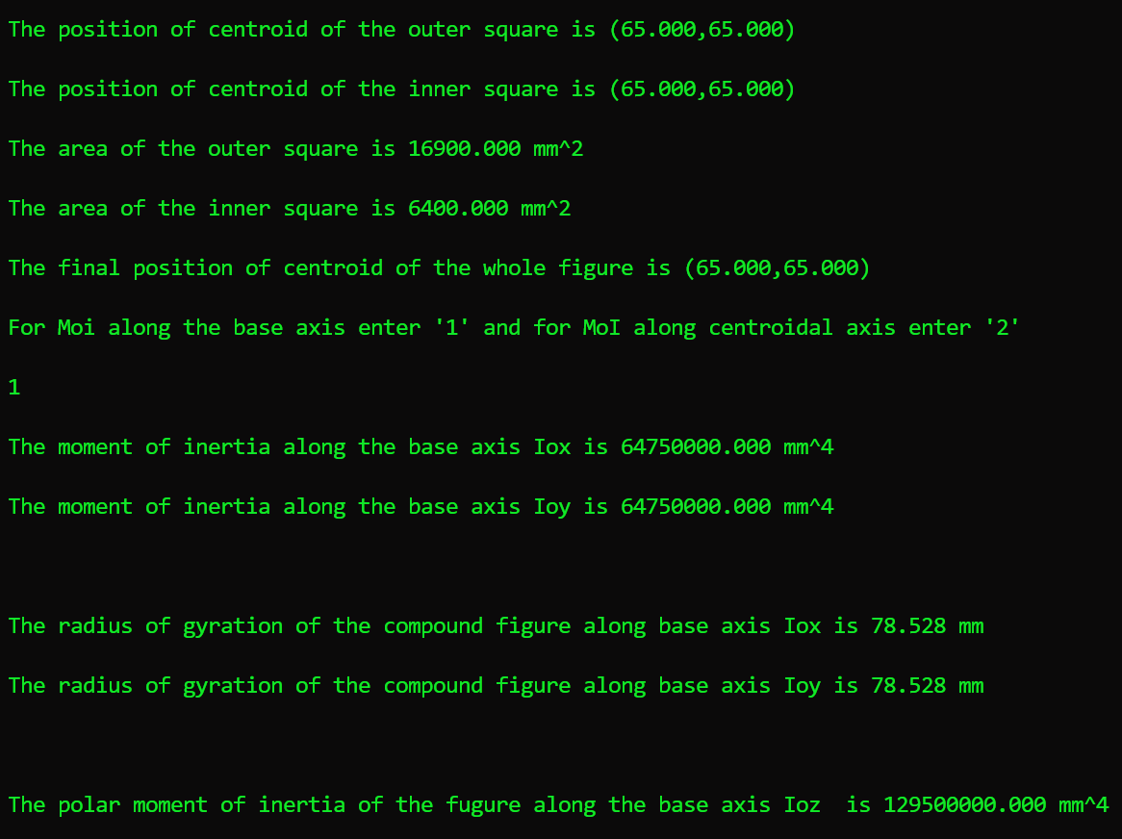



Find centre of gravity and moment of inertia along with radius of gyration of triangle with square cavity about base and centroidal axis. The base and height of triangle are 80.3mm, 69mm and side of square cavity is 20mm.

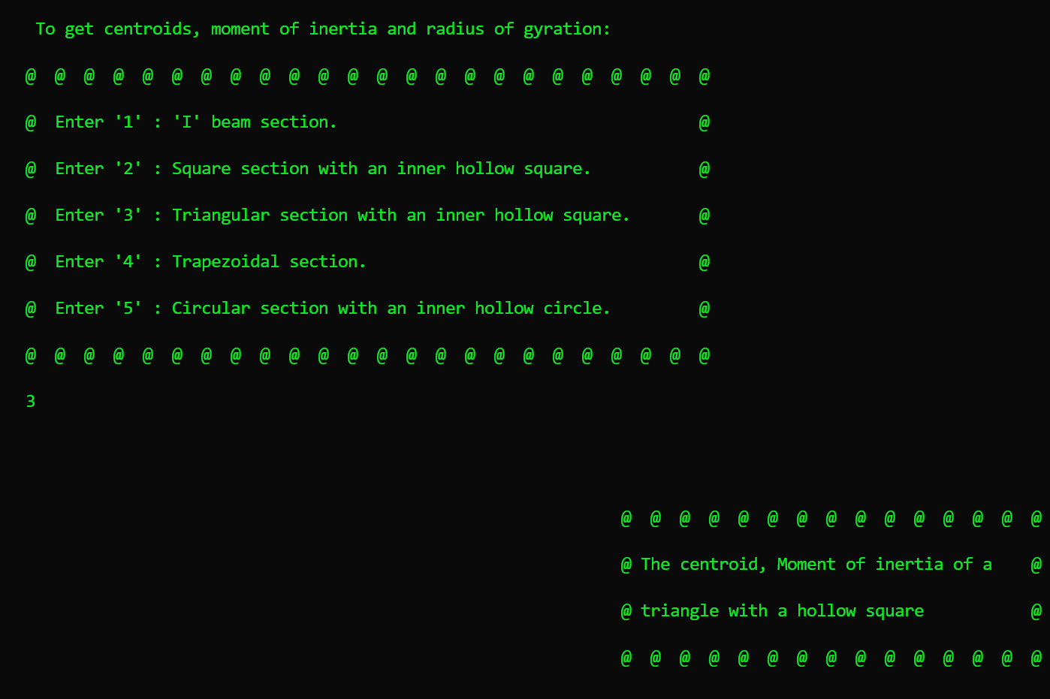

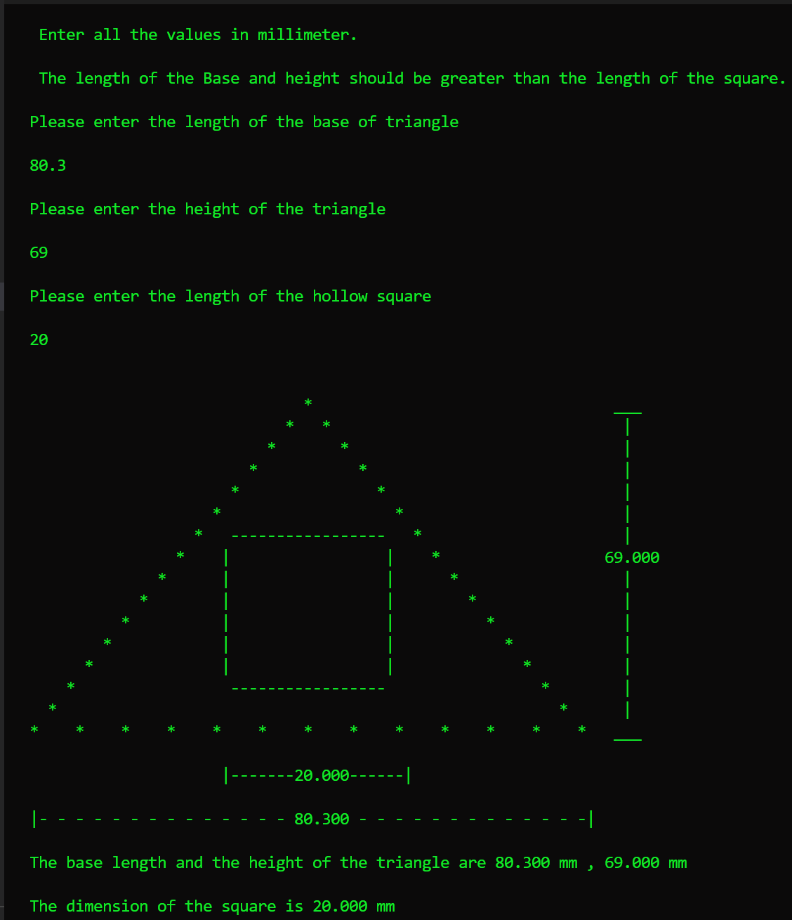

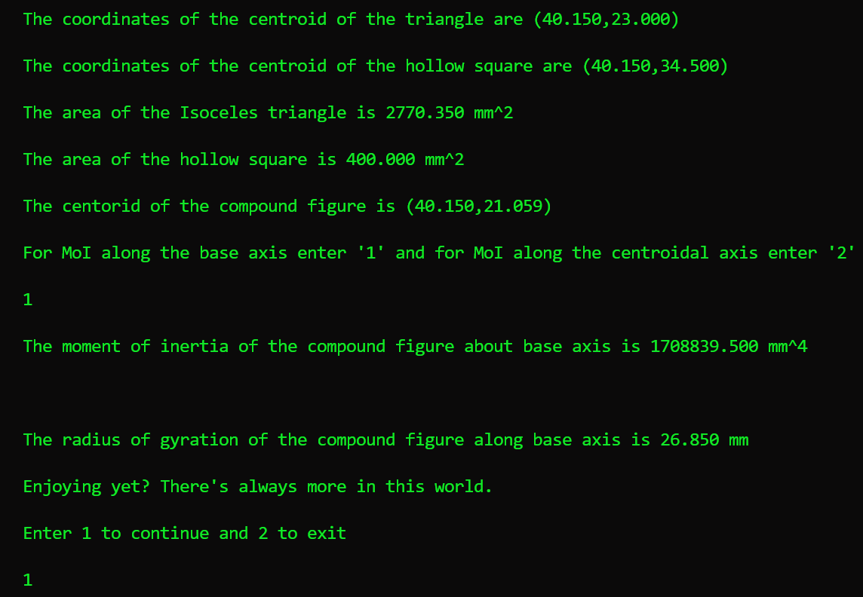

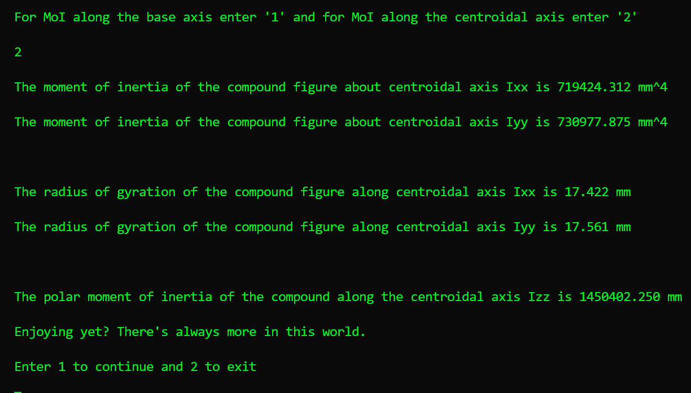

Find the cente of gravity and moment of inertia of trapezium of sides 120mm, 70mm and height 50mm about centroidal axis and base axis. Also find the radius of gyration.

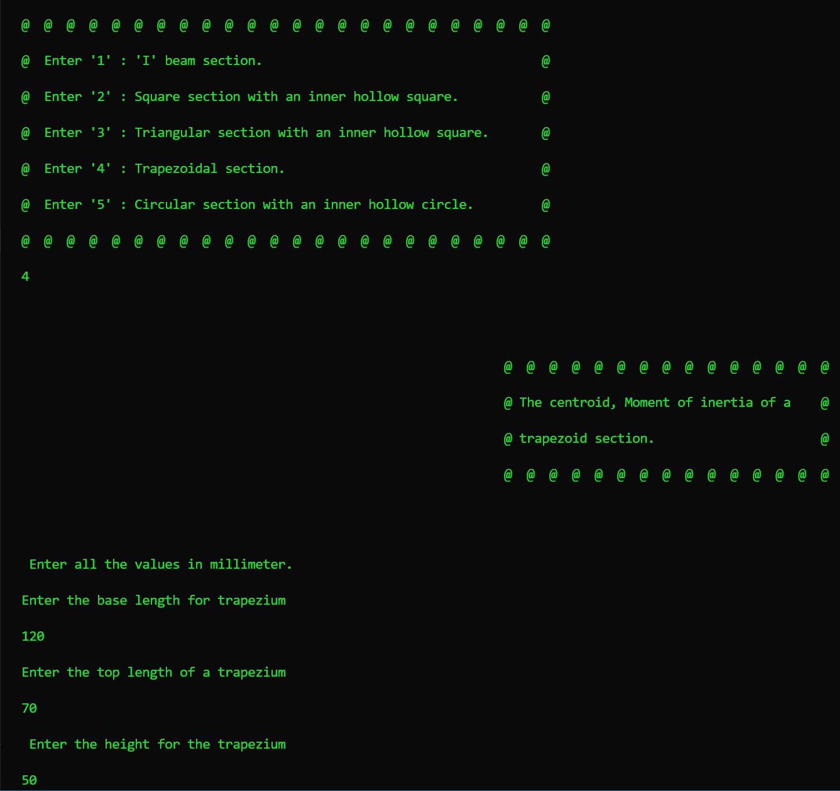

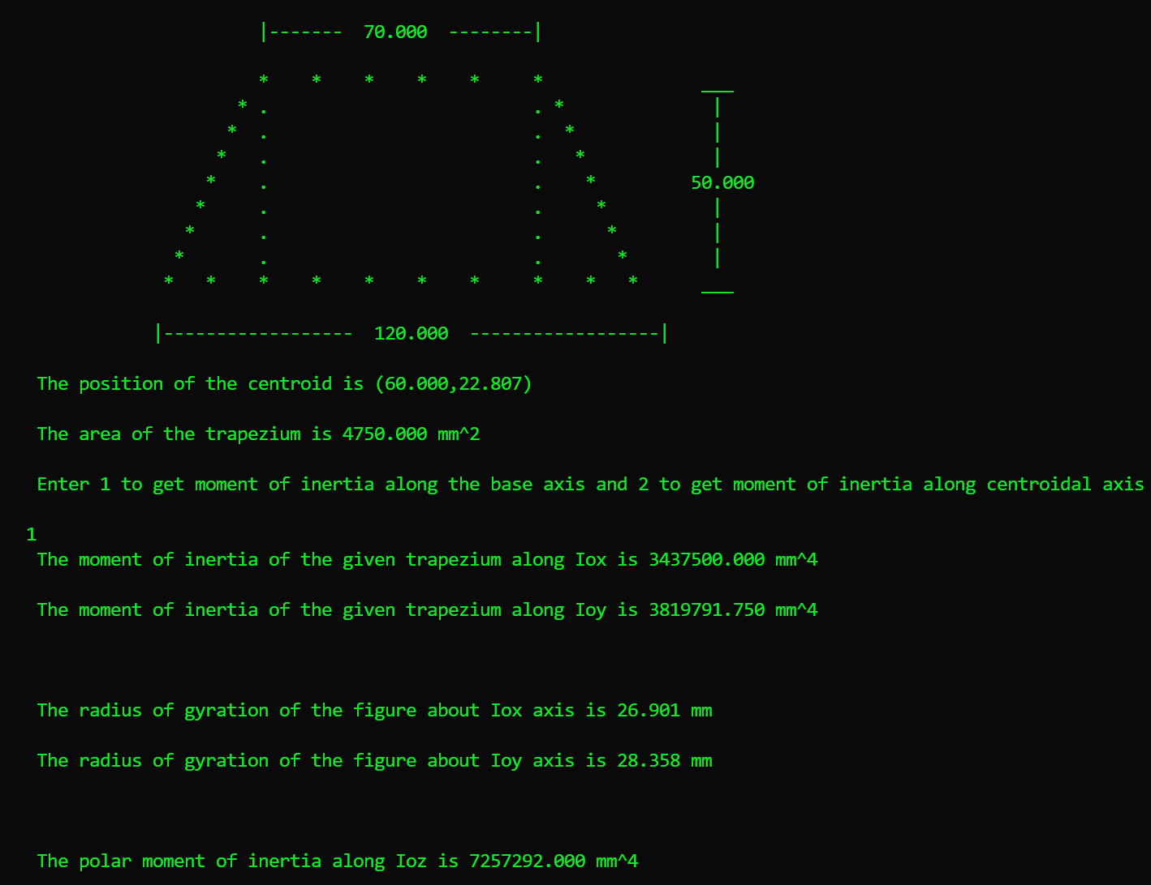

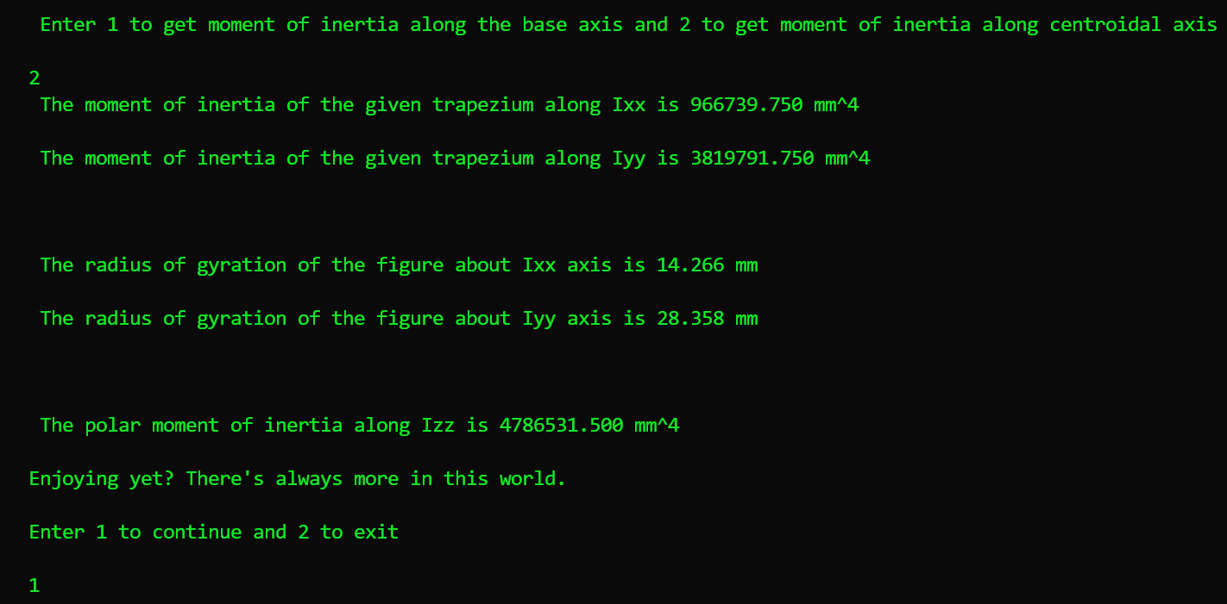

Find moment of inertia , centre of gravity and radius of gyration of hollow circle of radius 40mm and circular cavity of radius 20mm . Also find its radius of gyration.

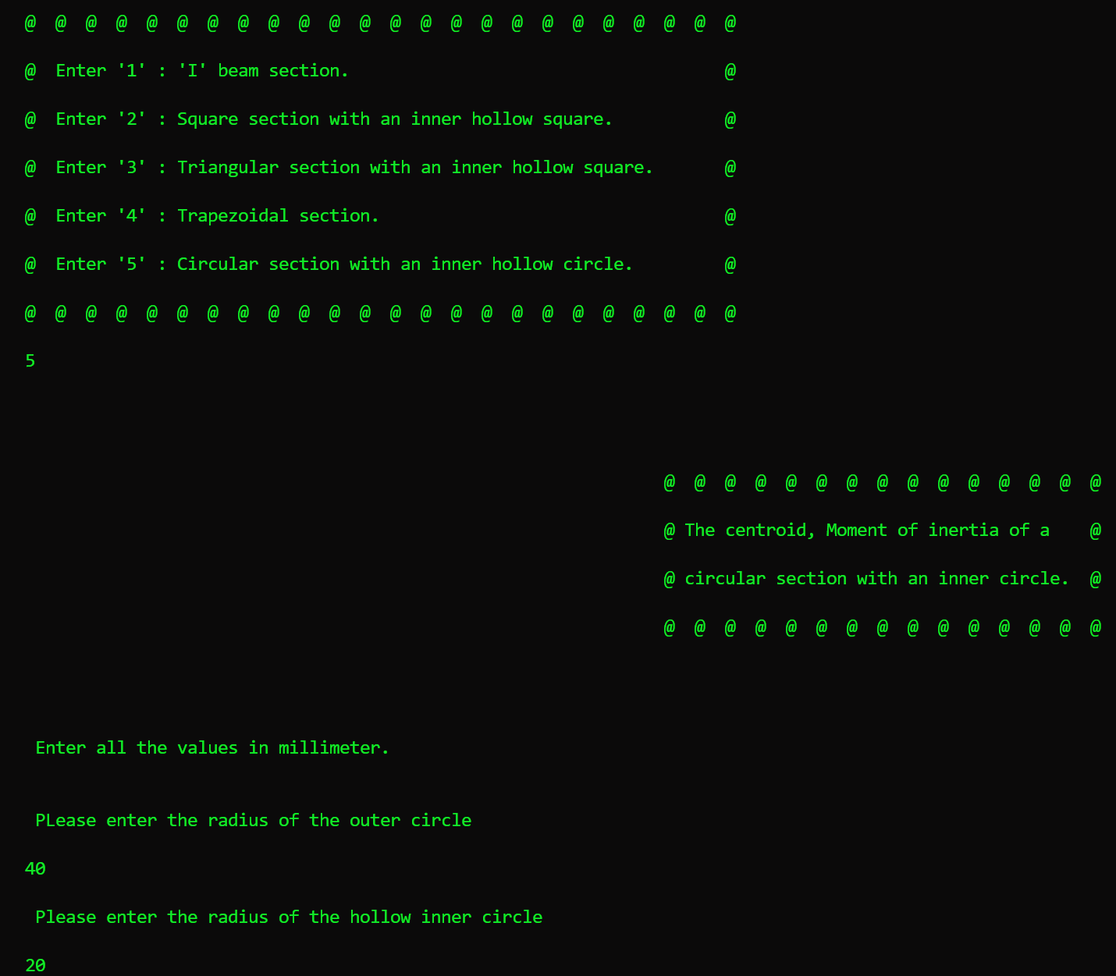

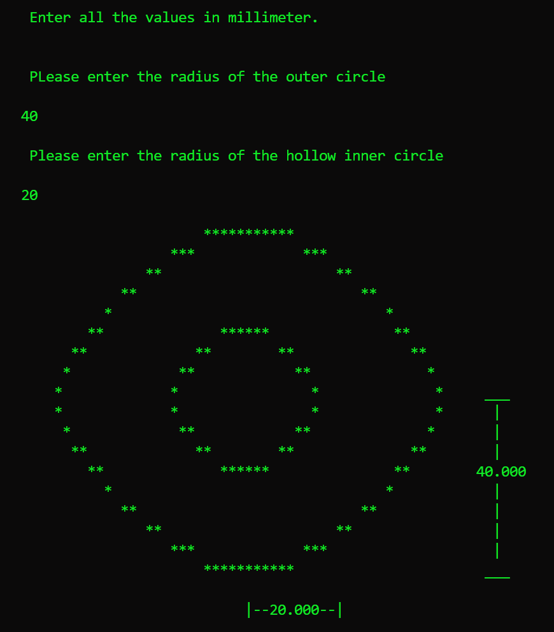

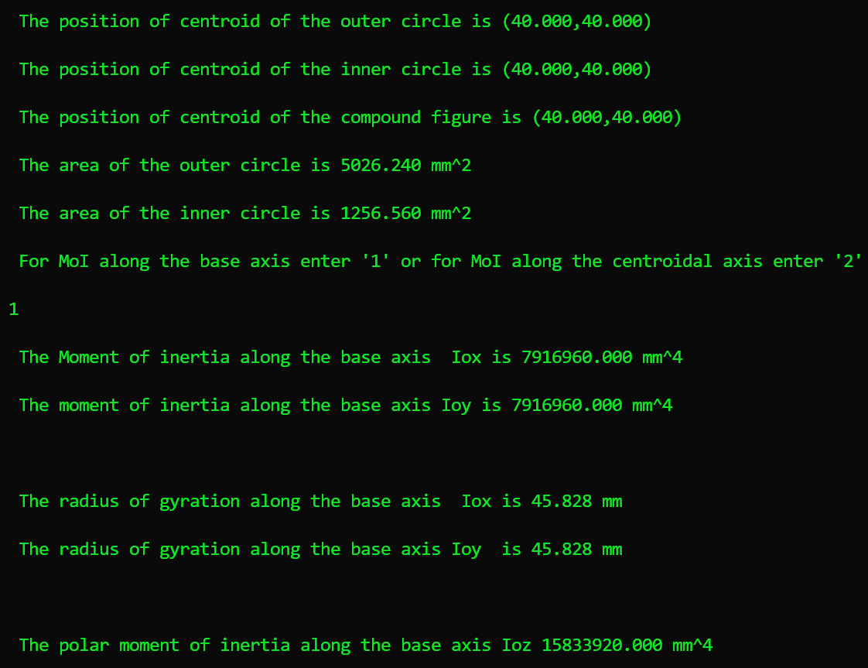

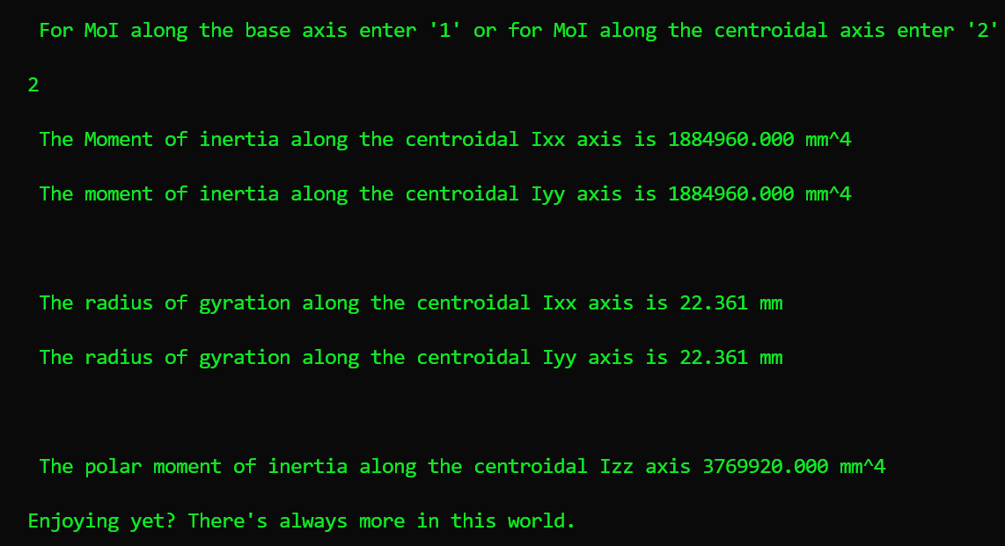

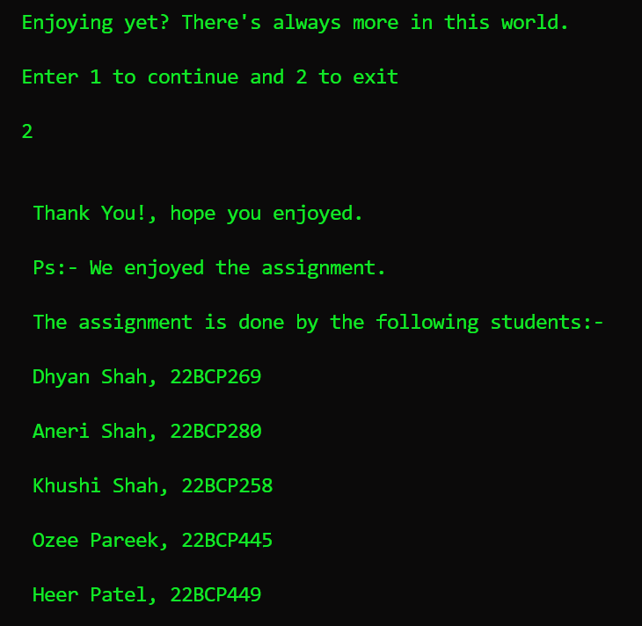

Code

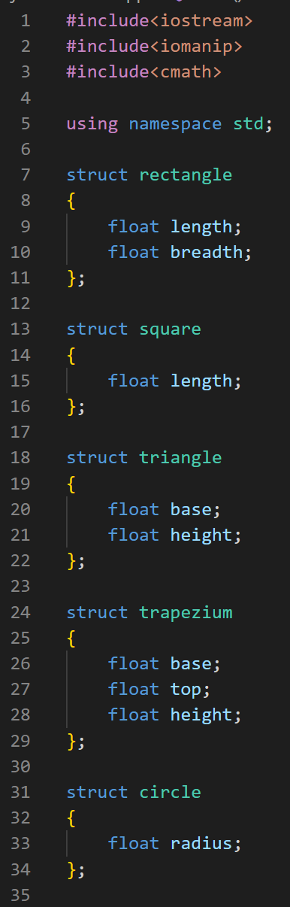

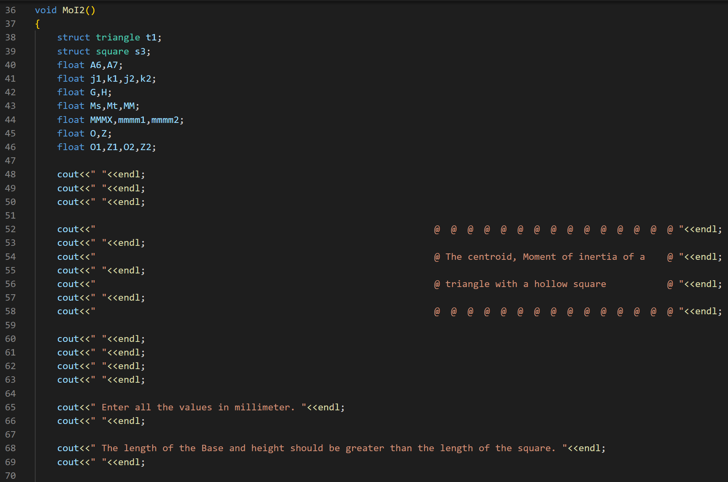

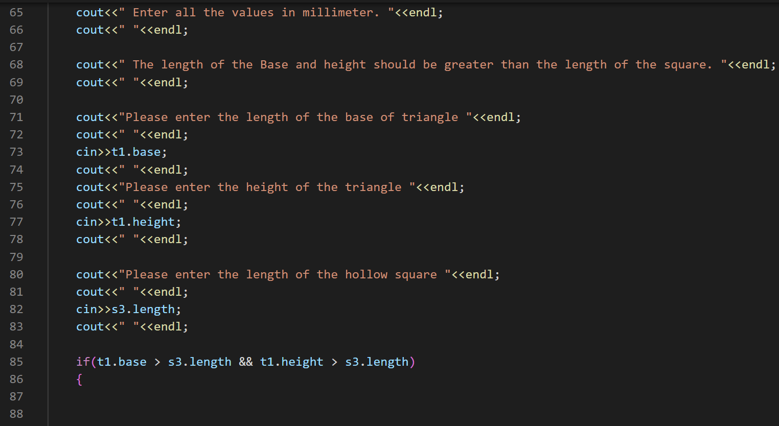

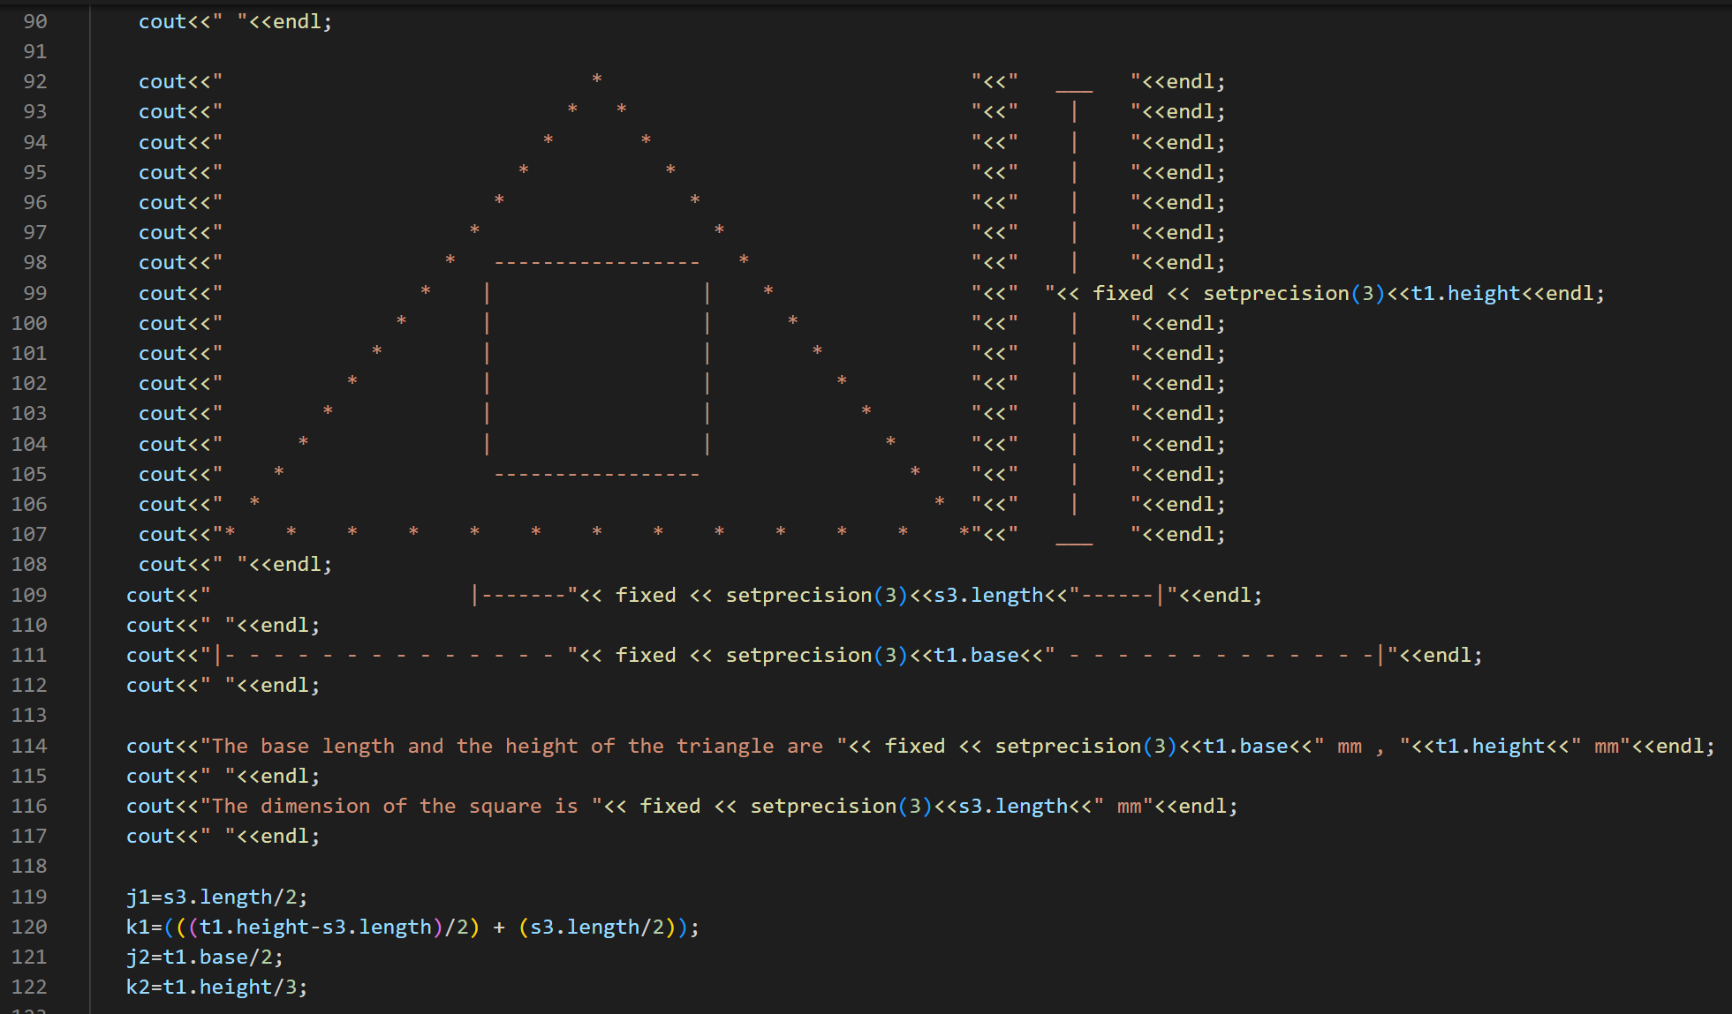

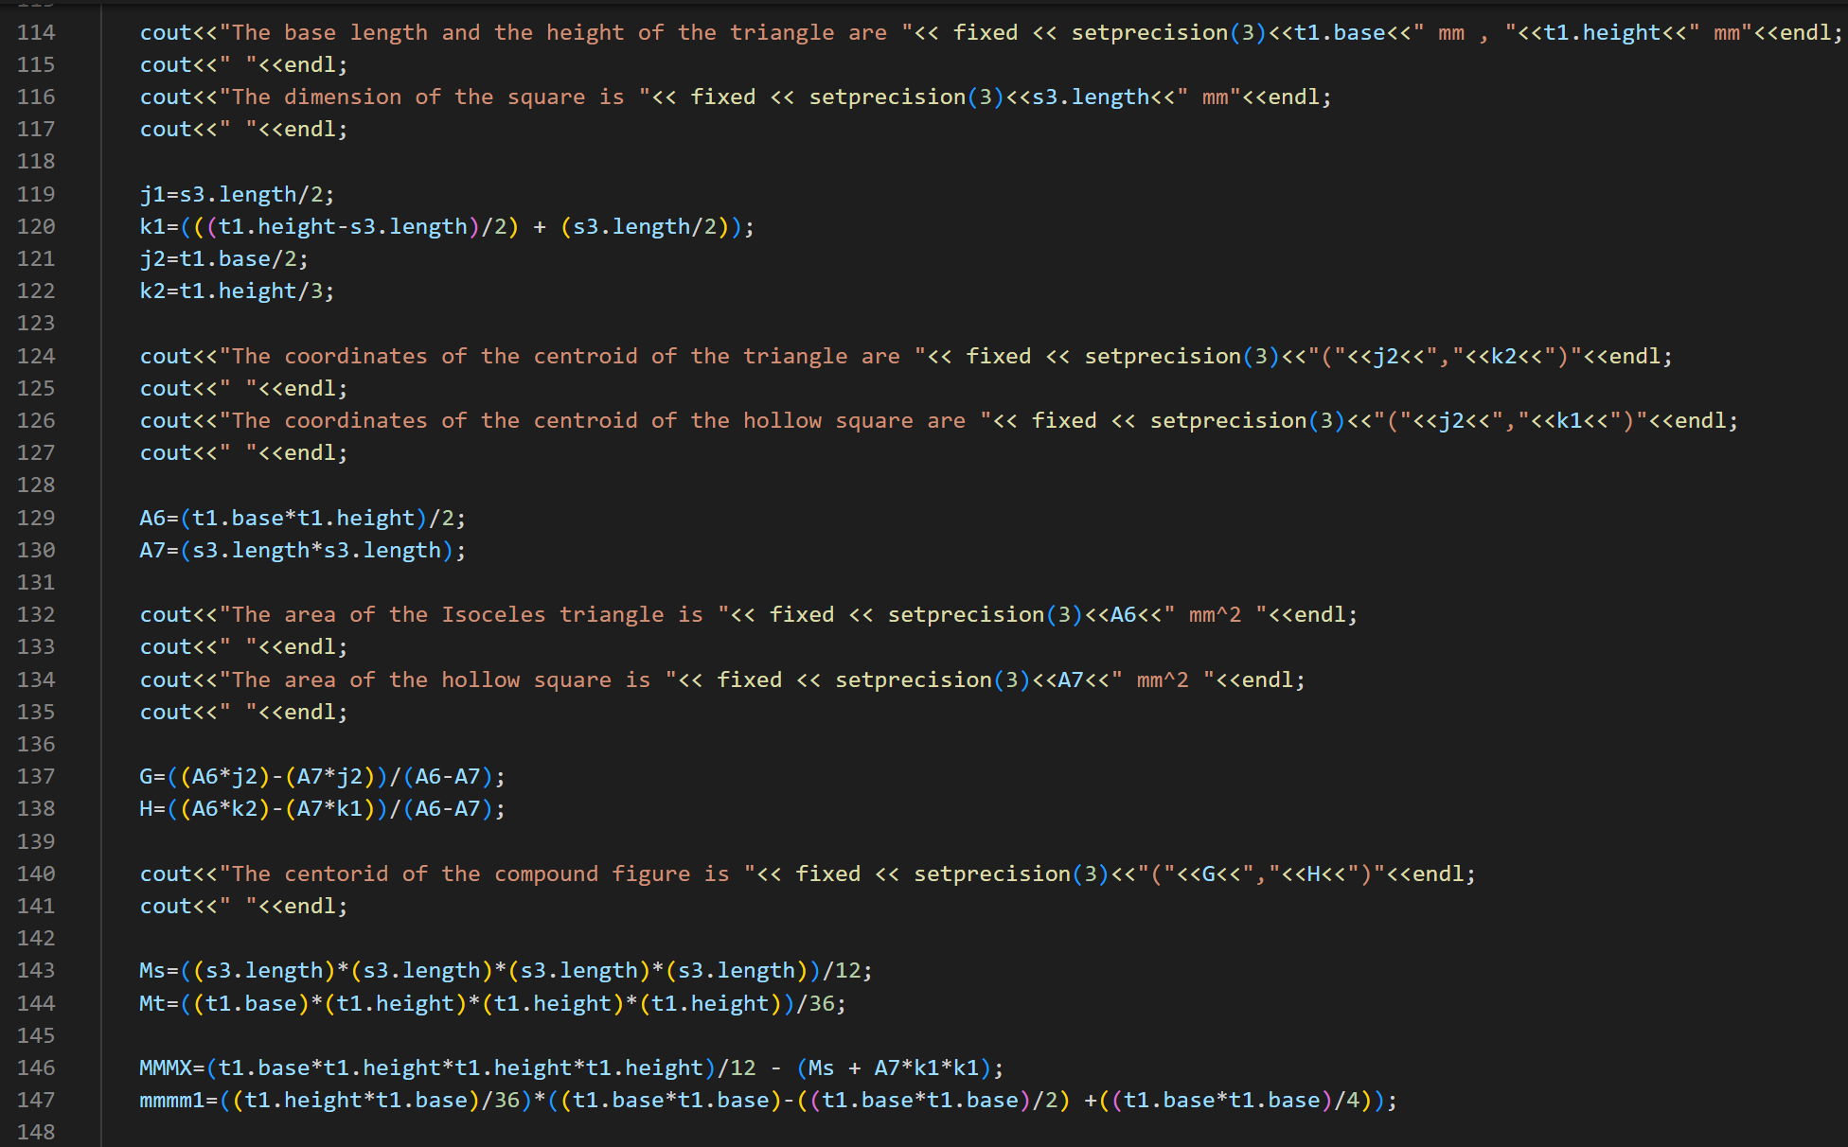

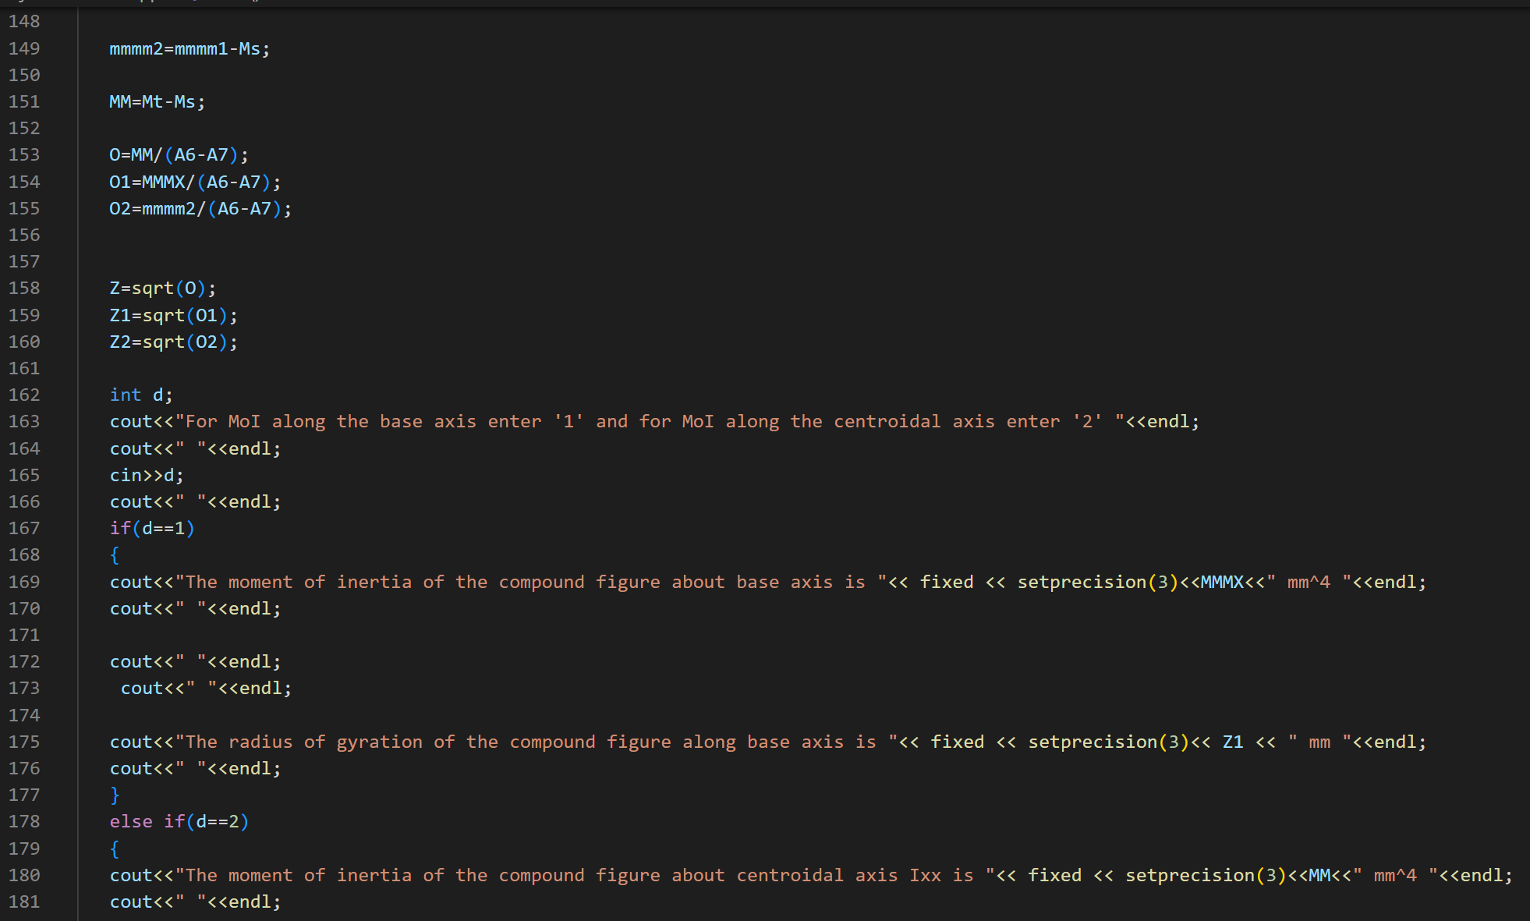

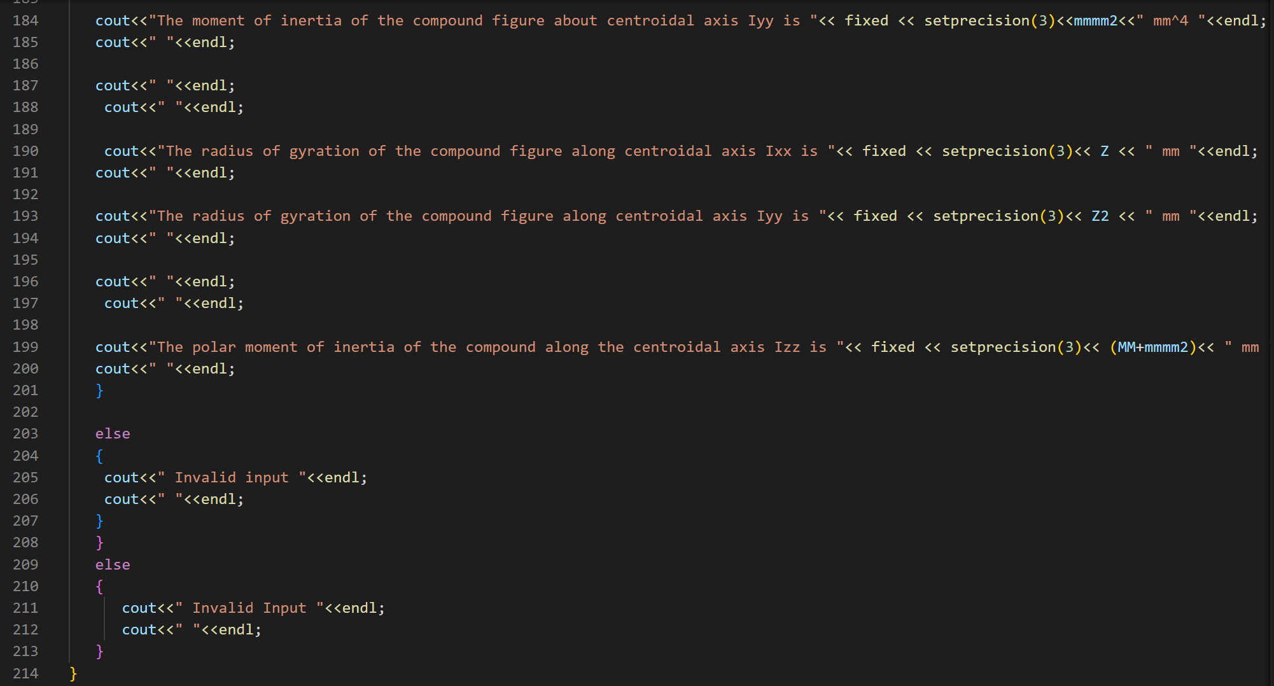

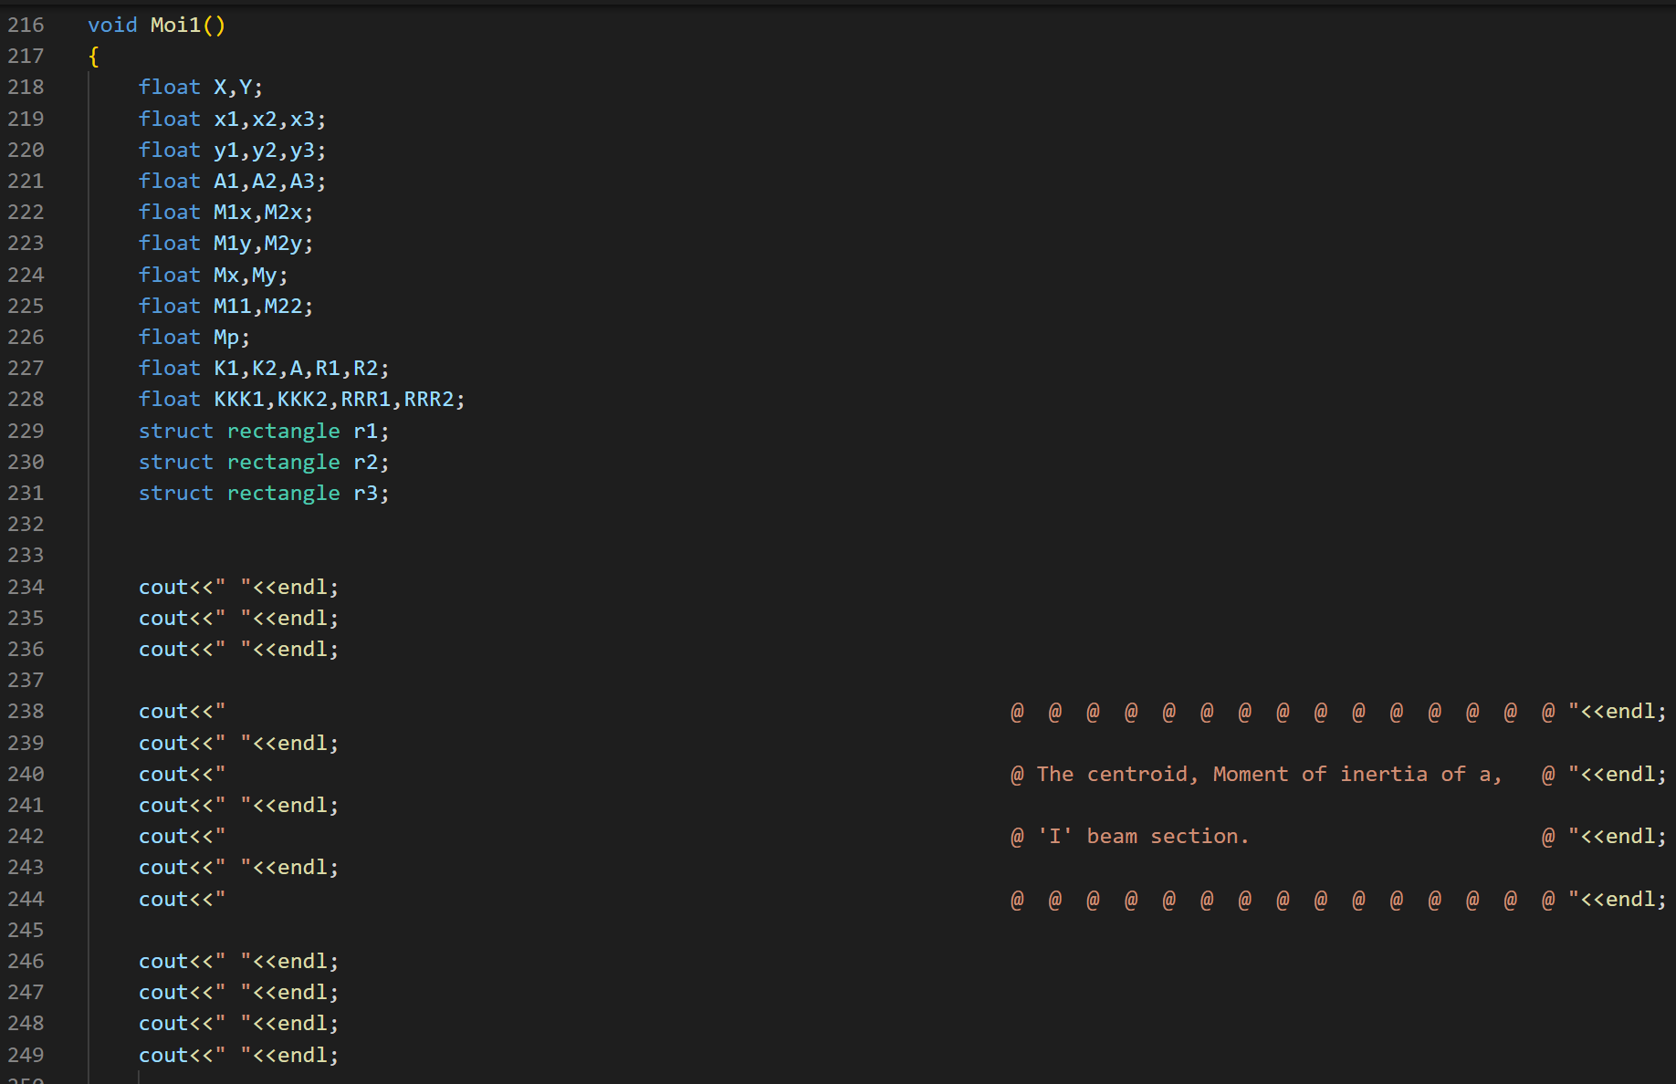

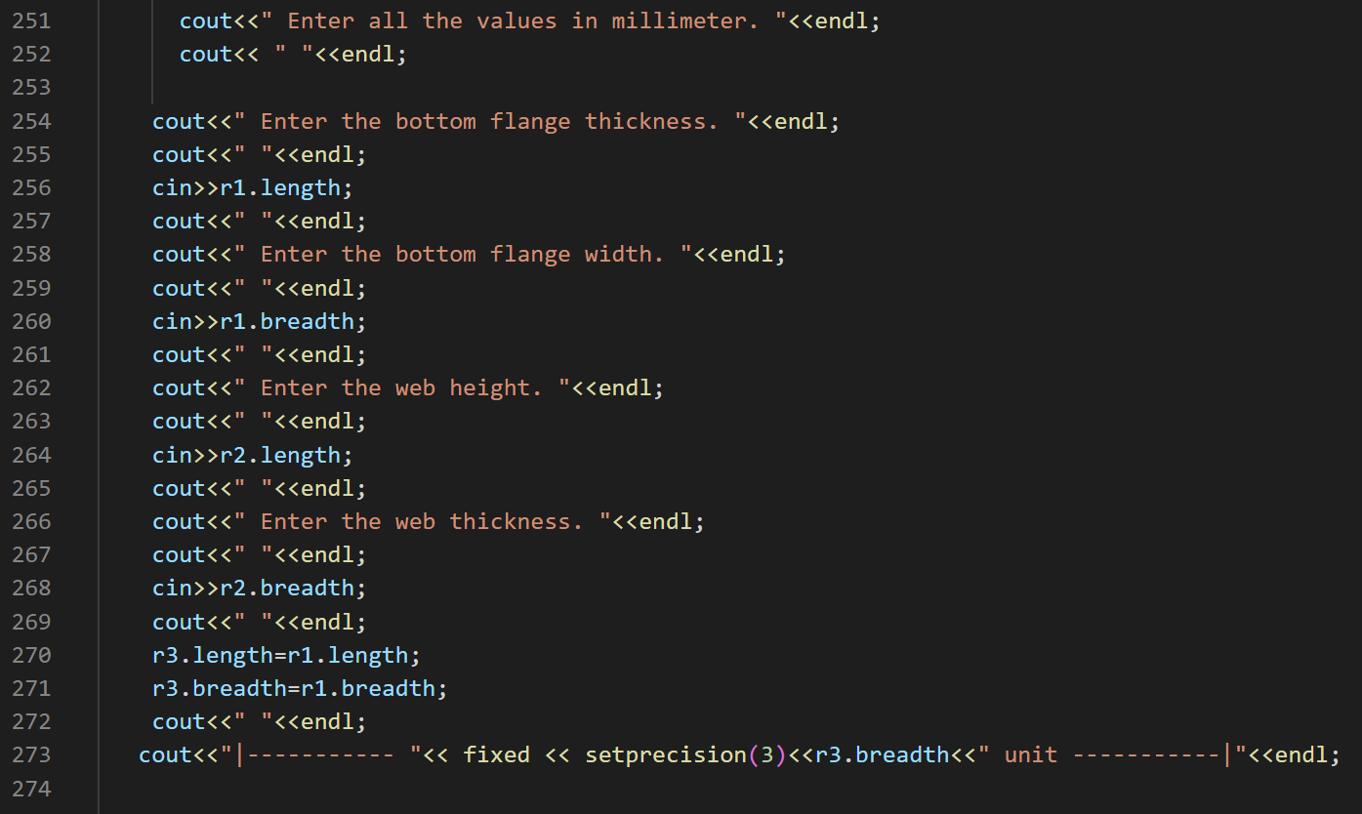

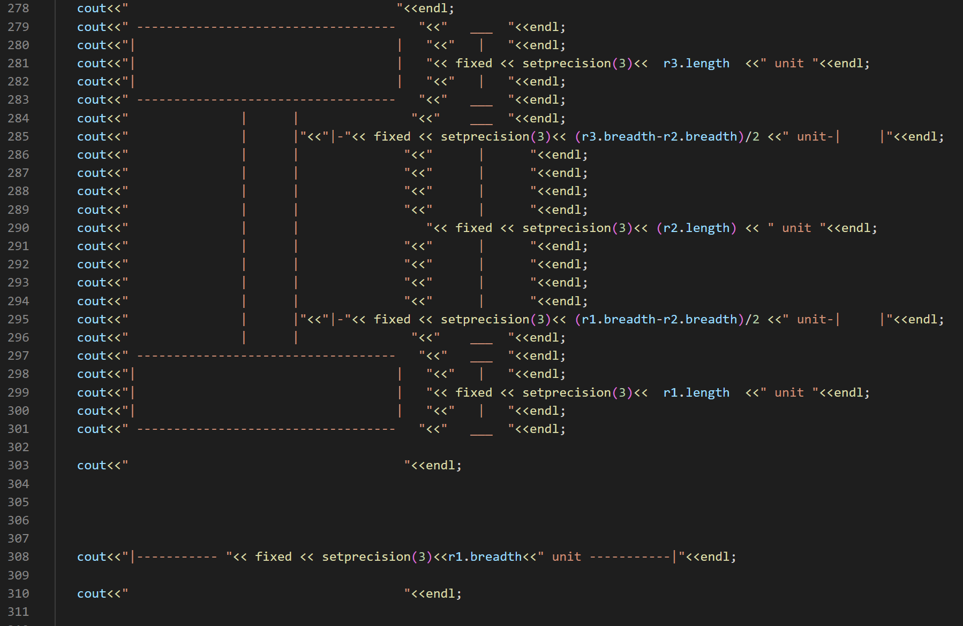

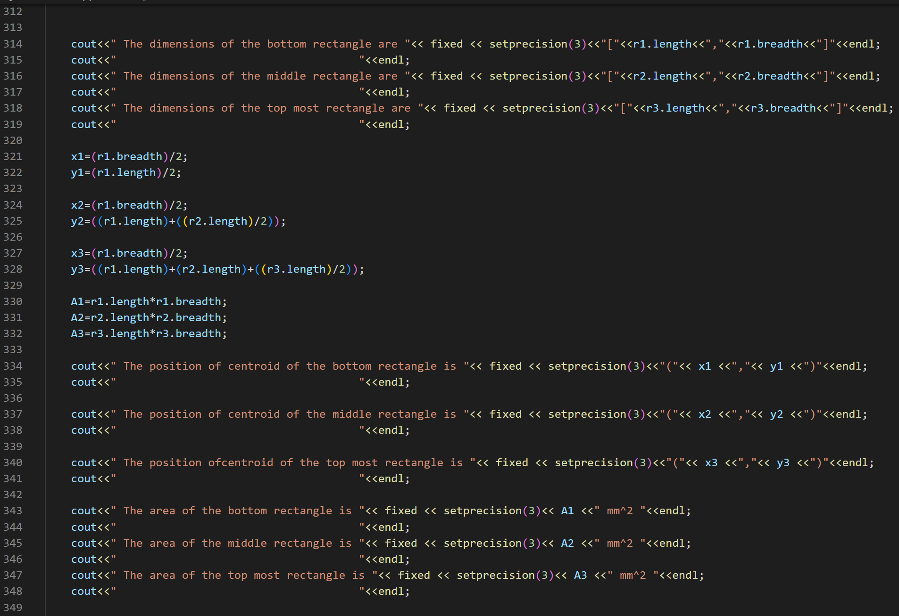

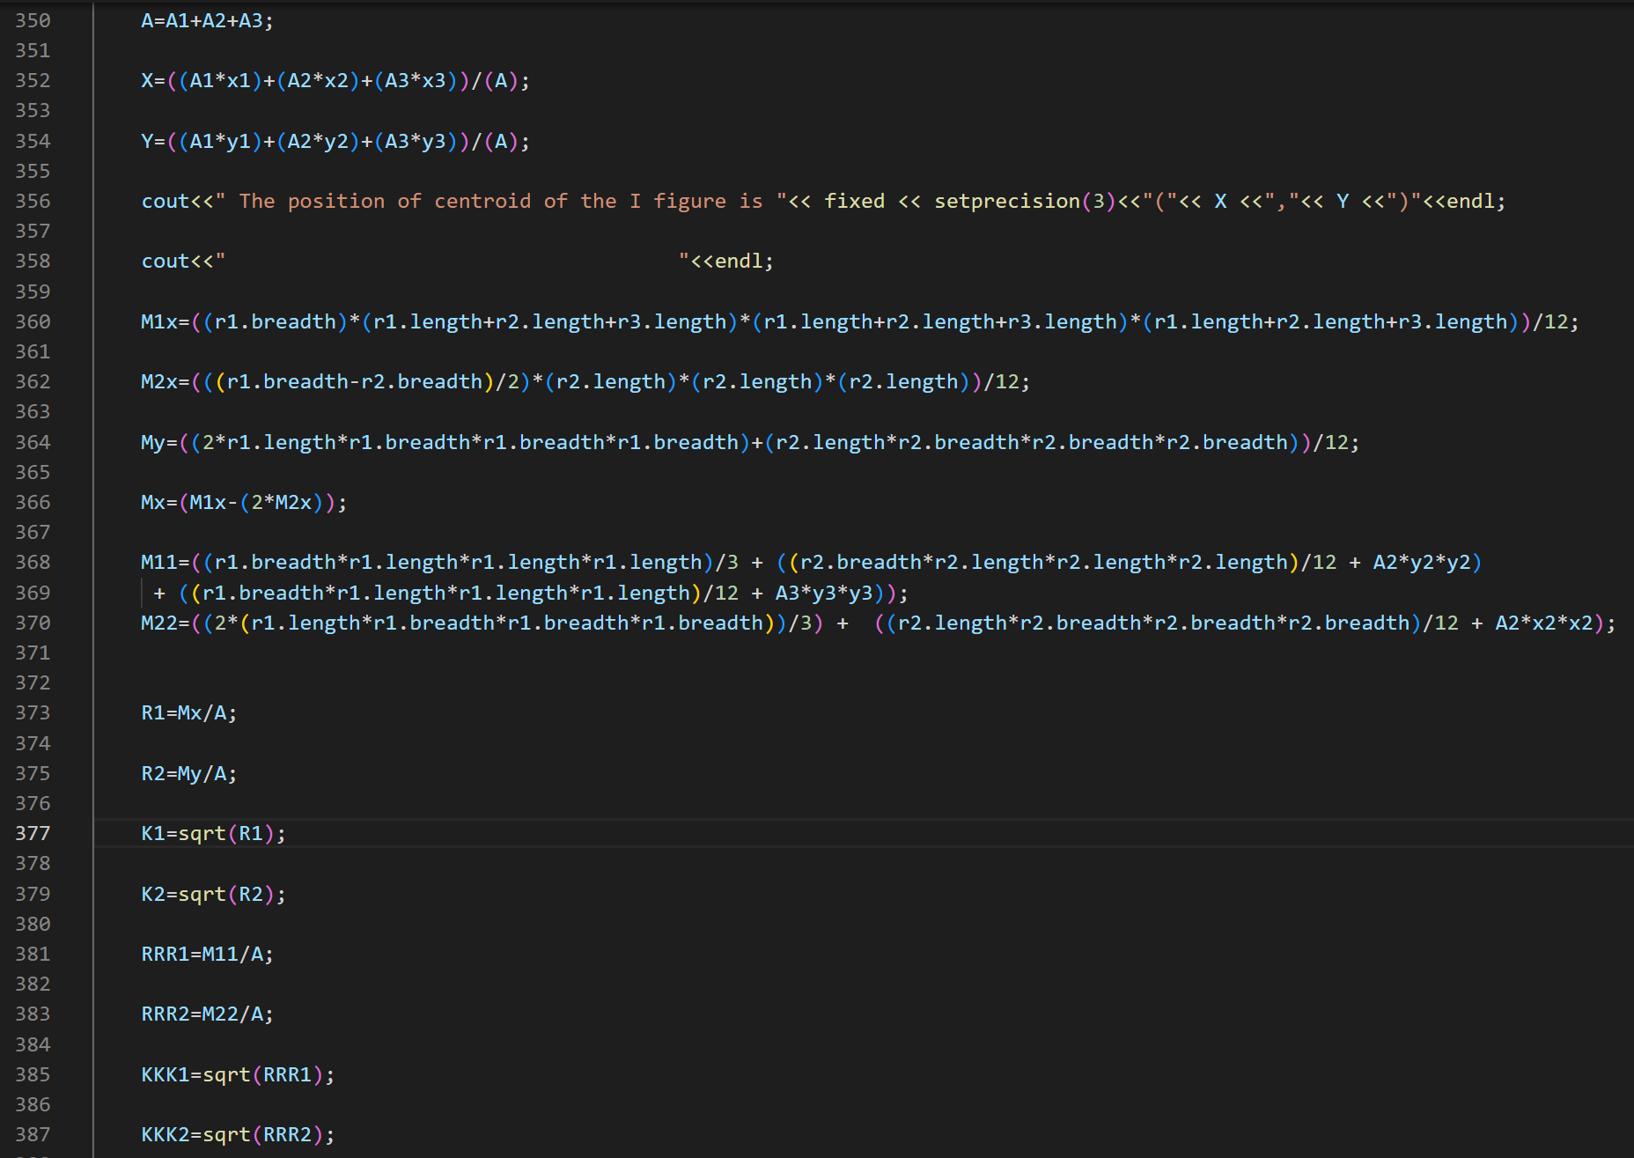

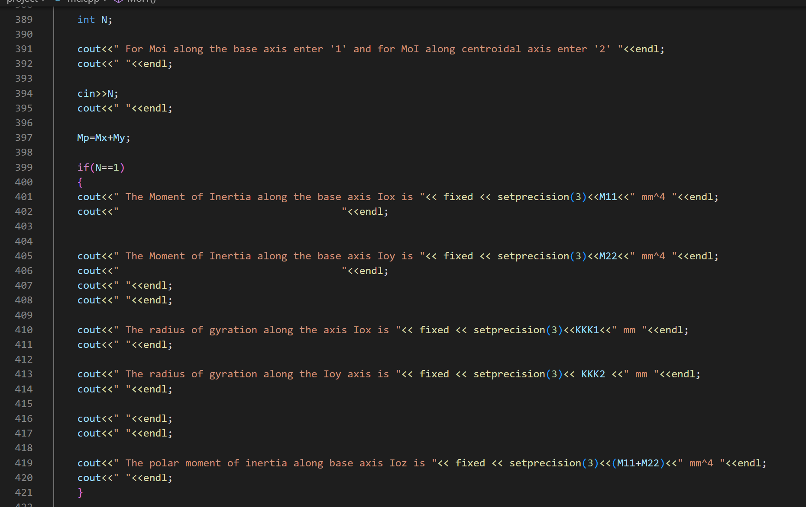

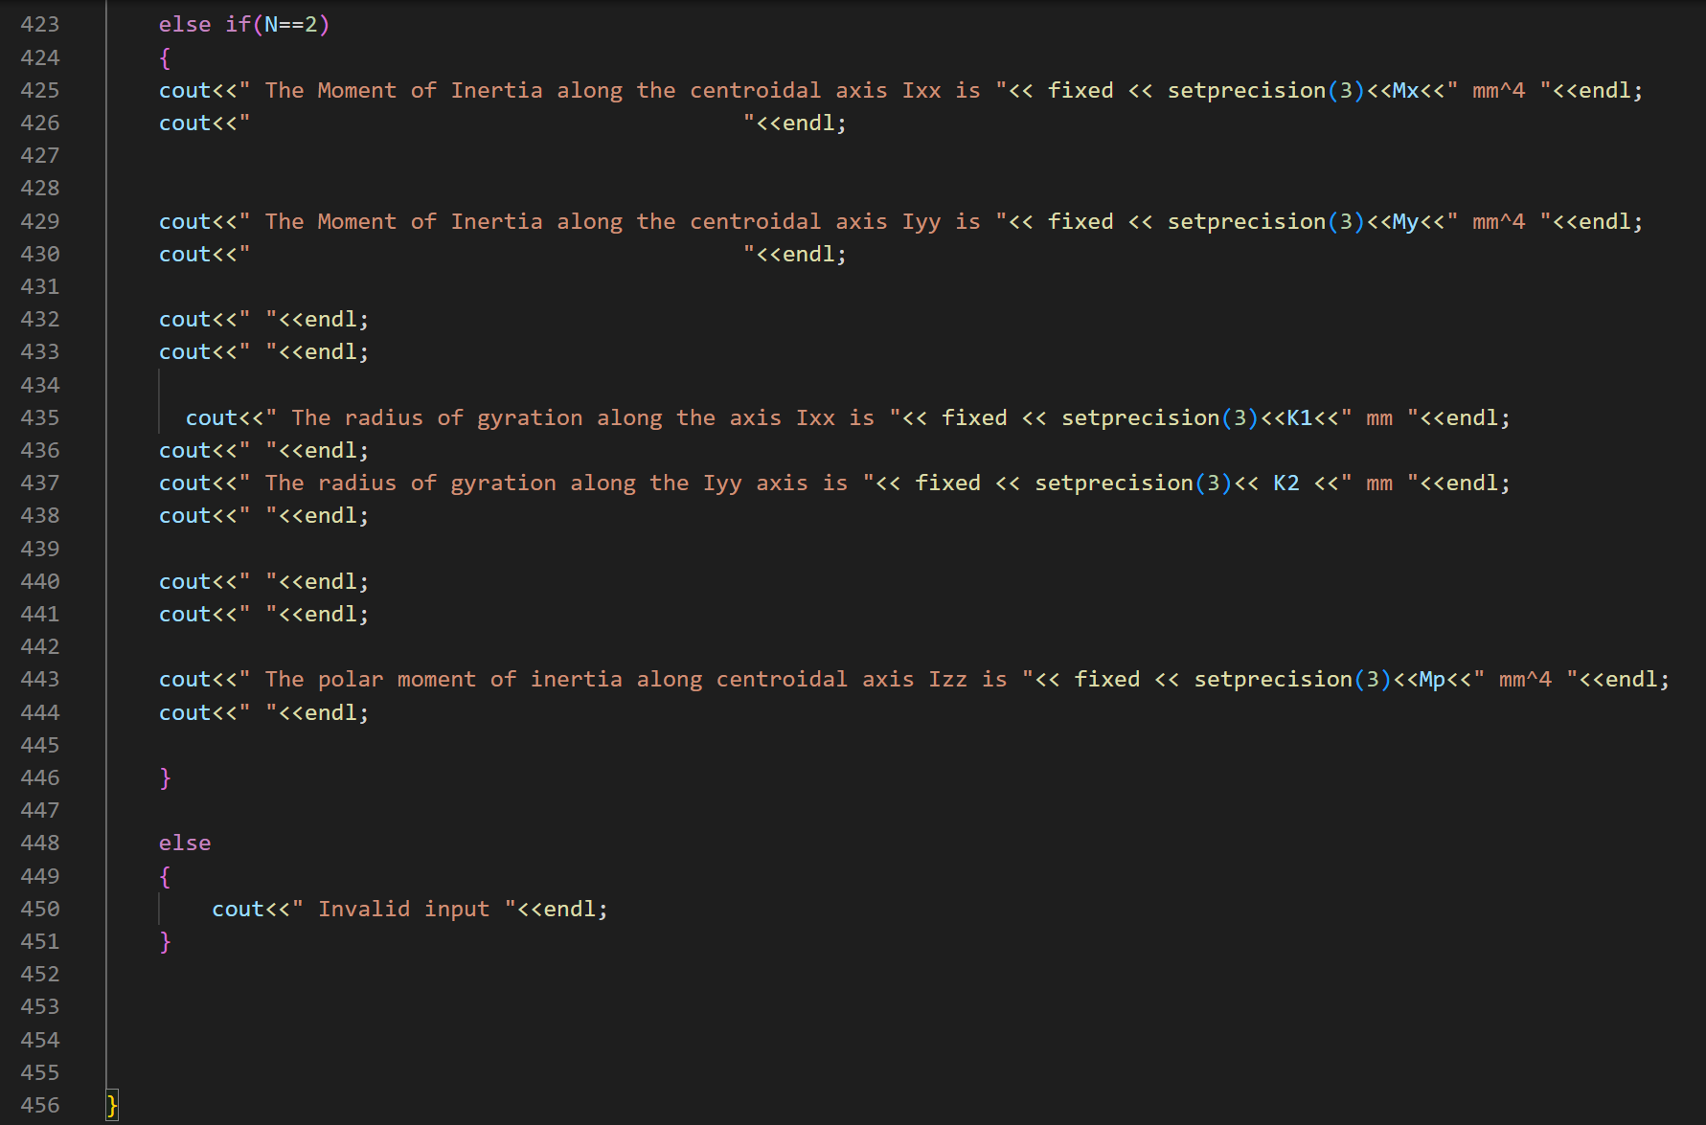

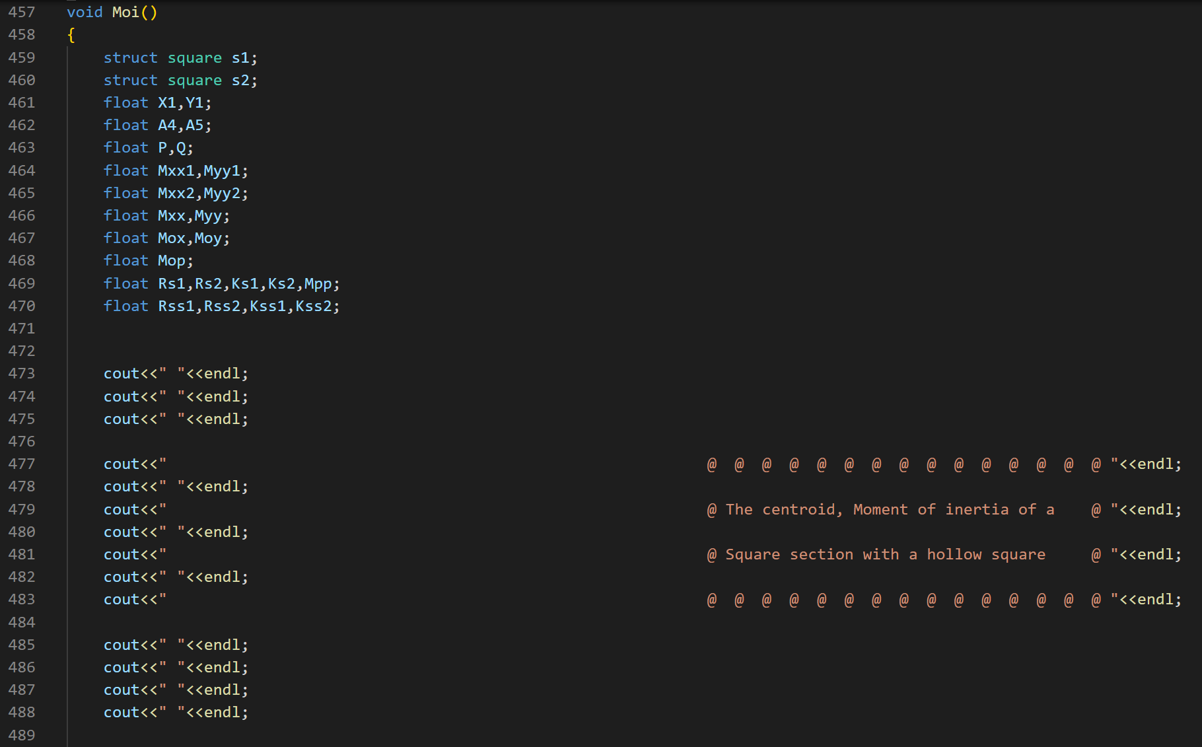

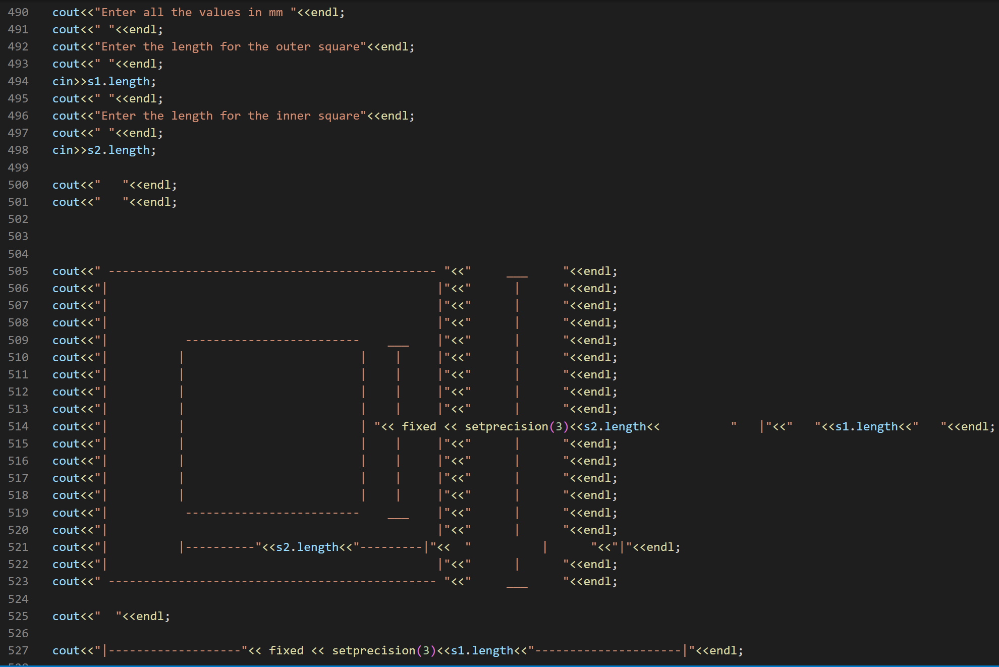

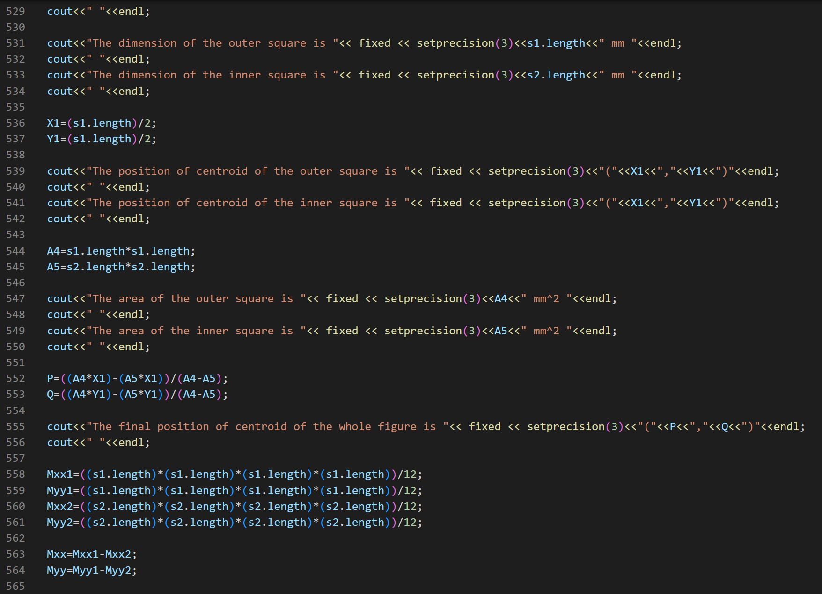

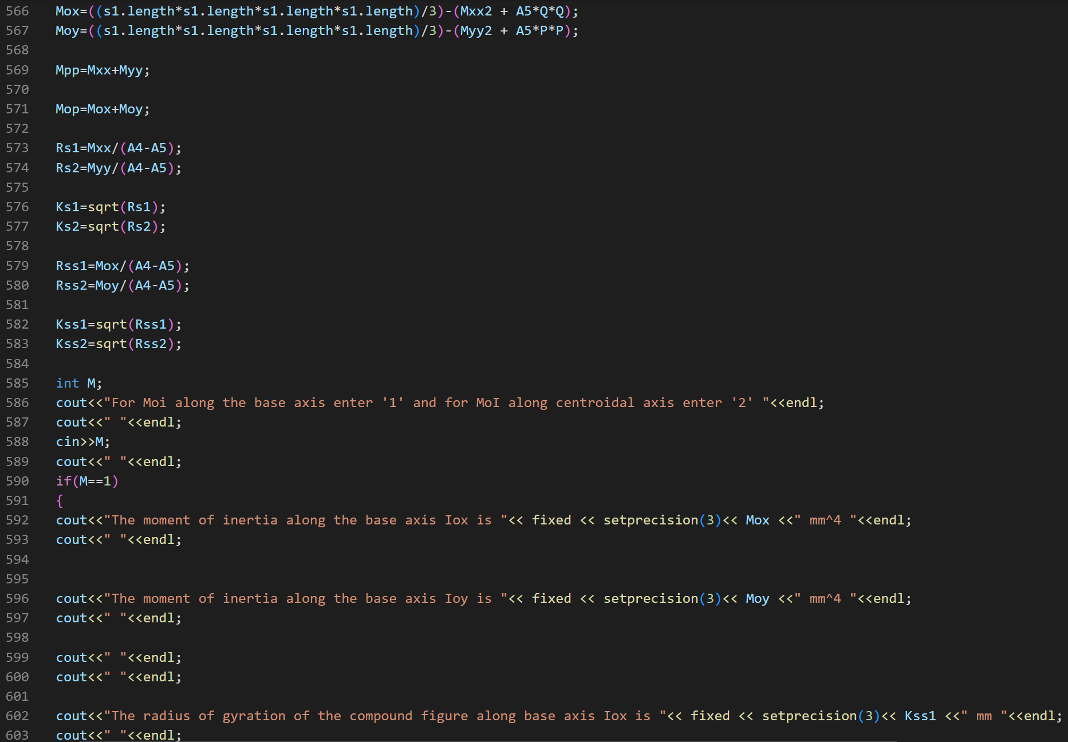

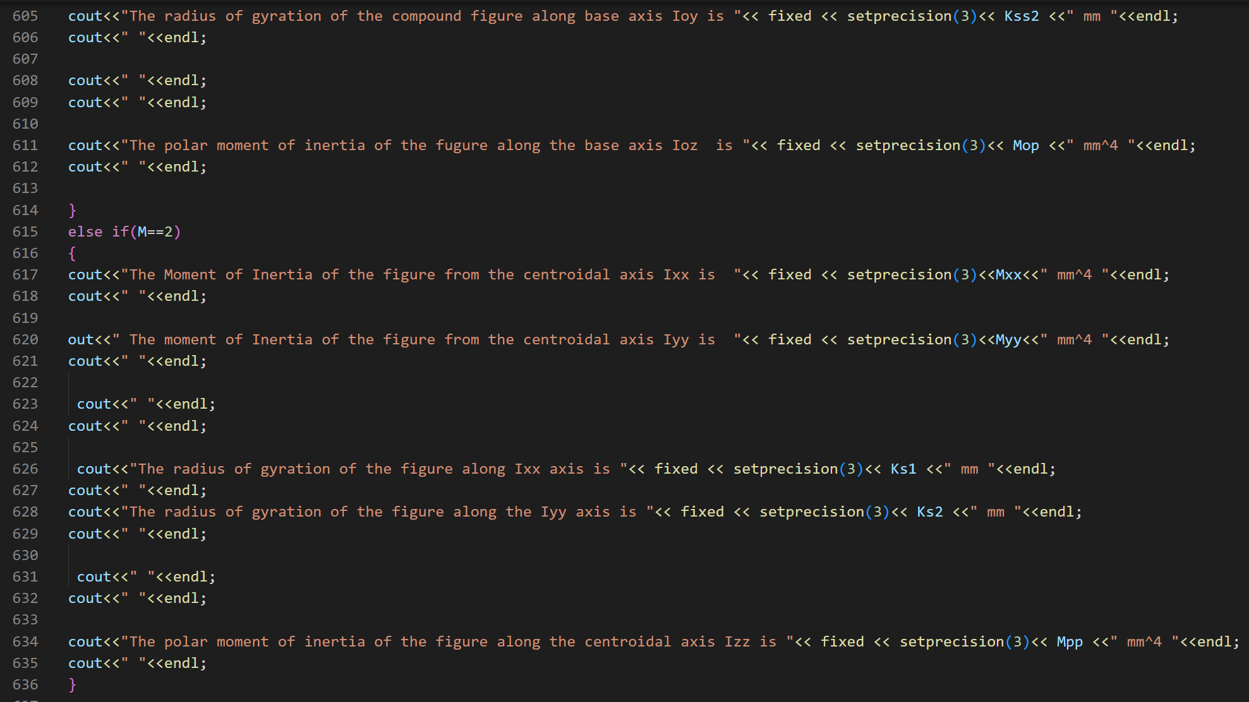

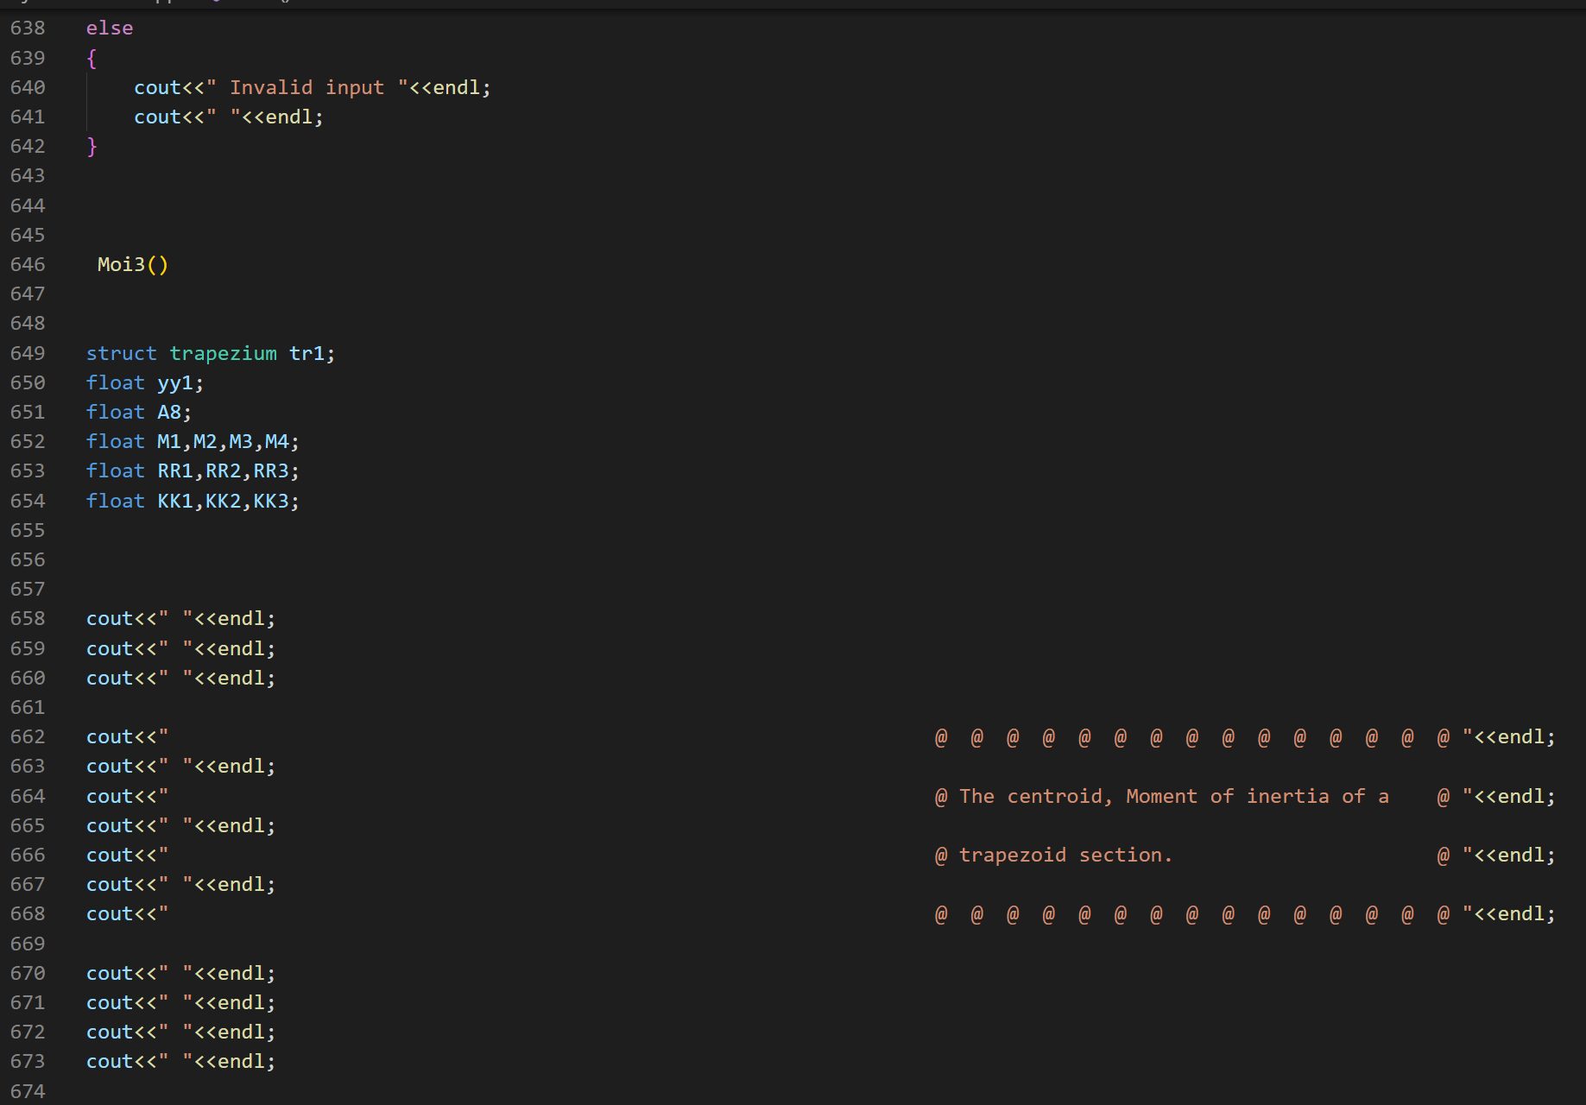

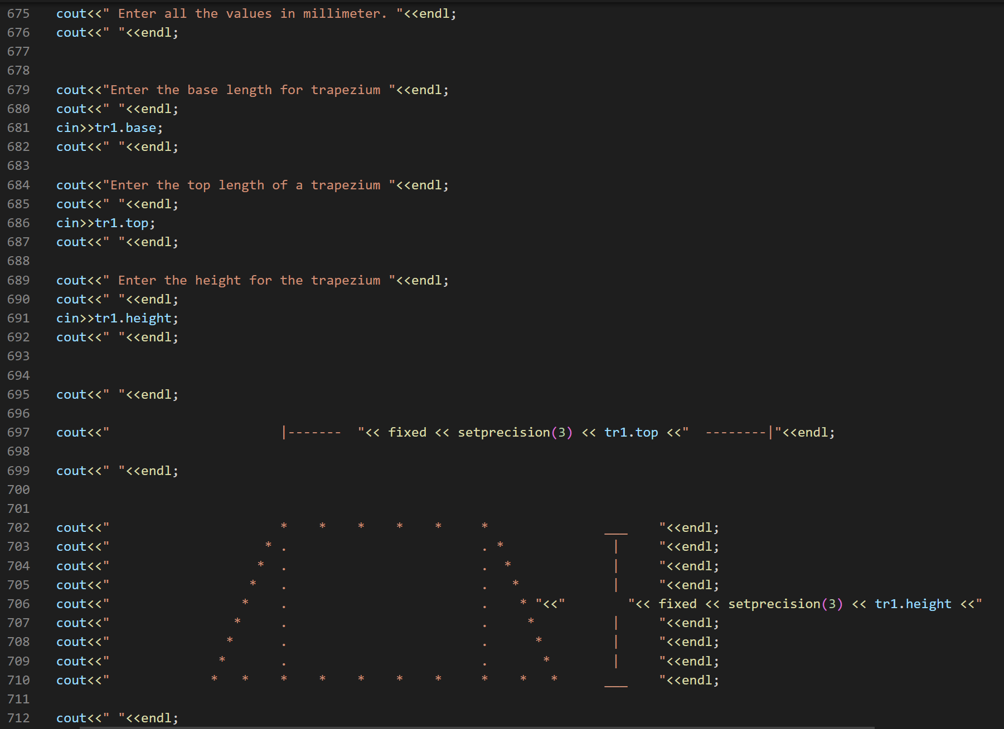

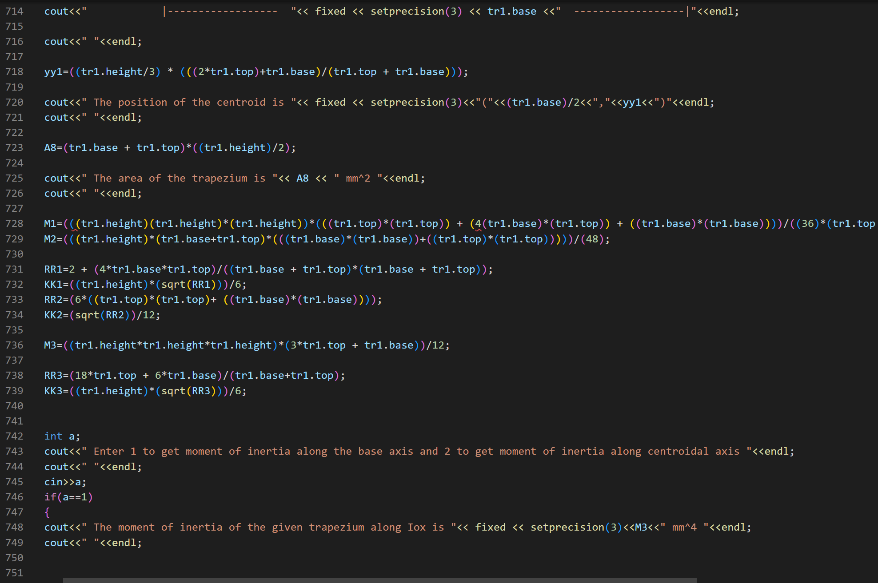

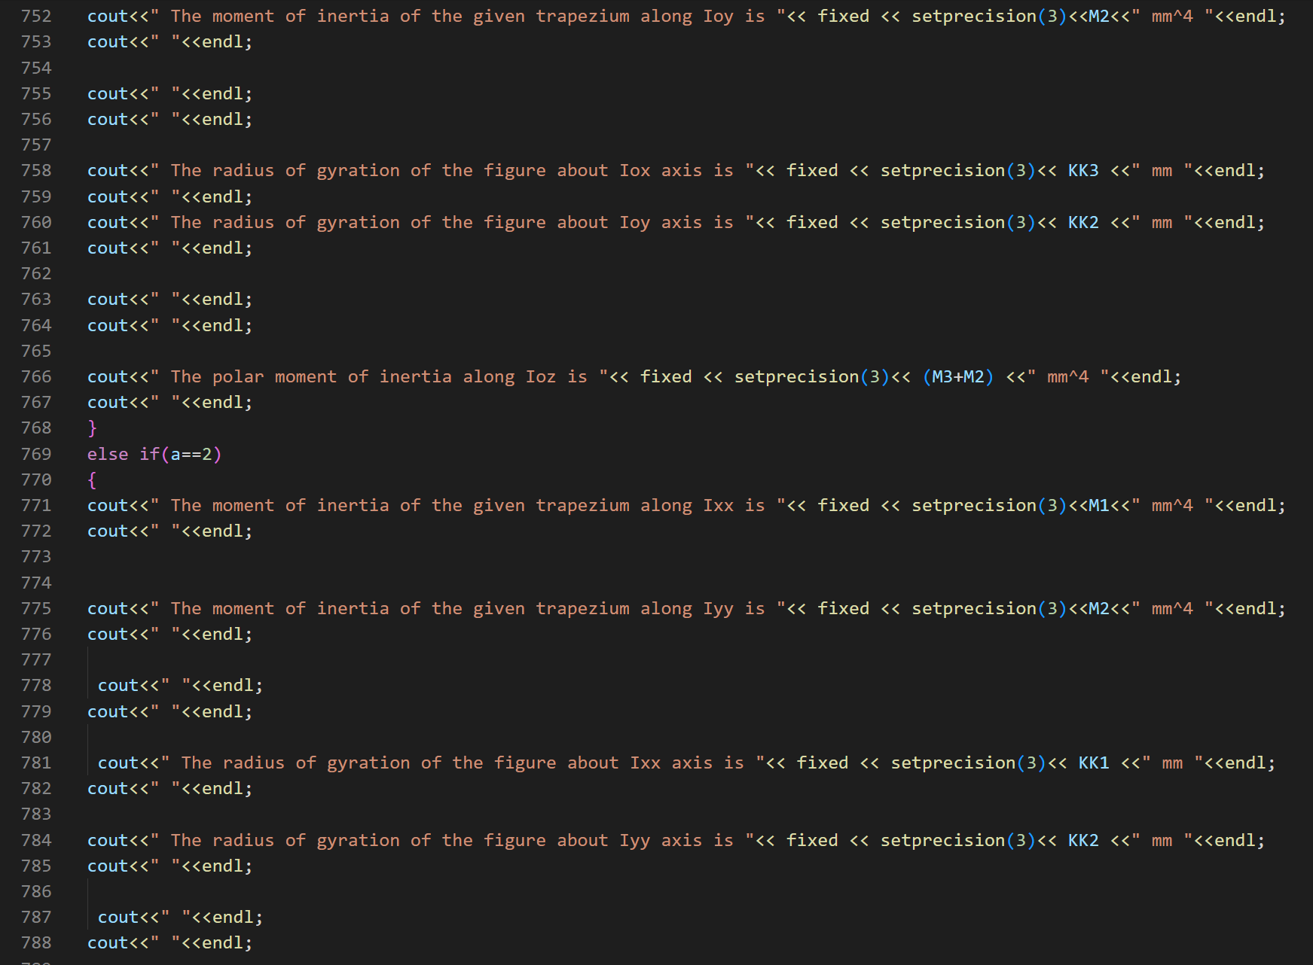

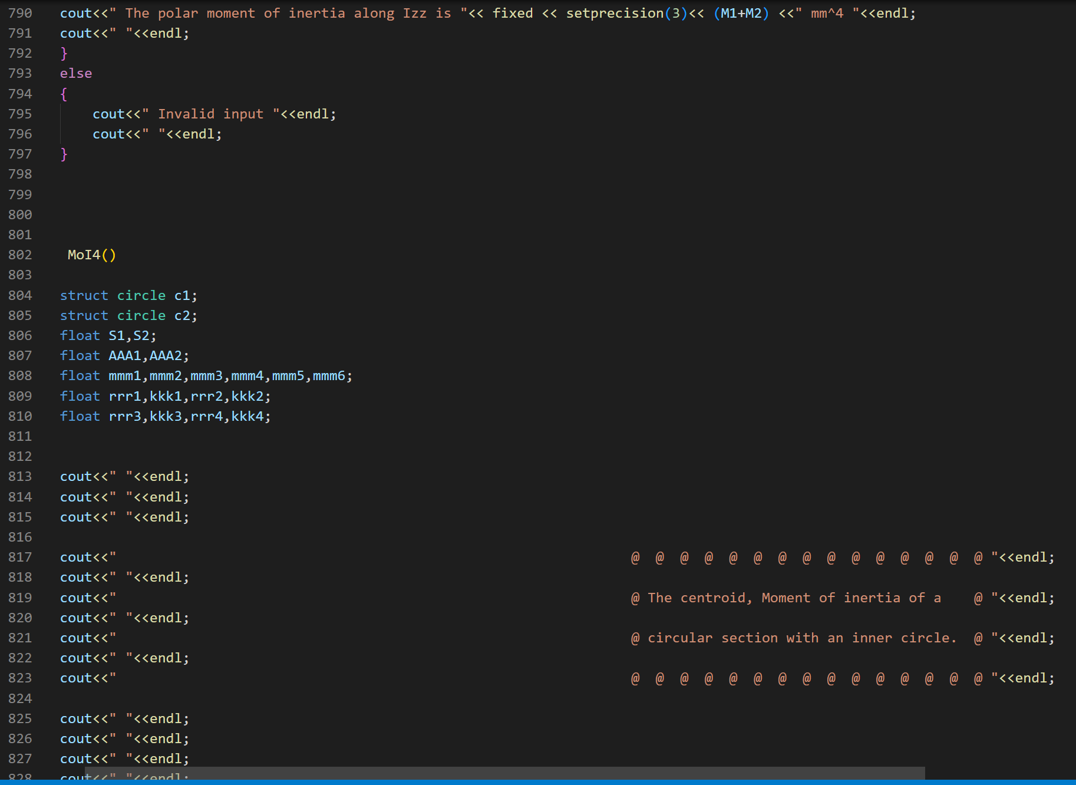

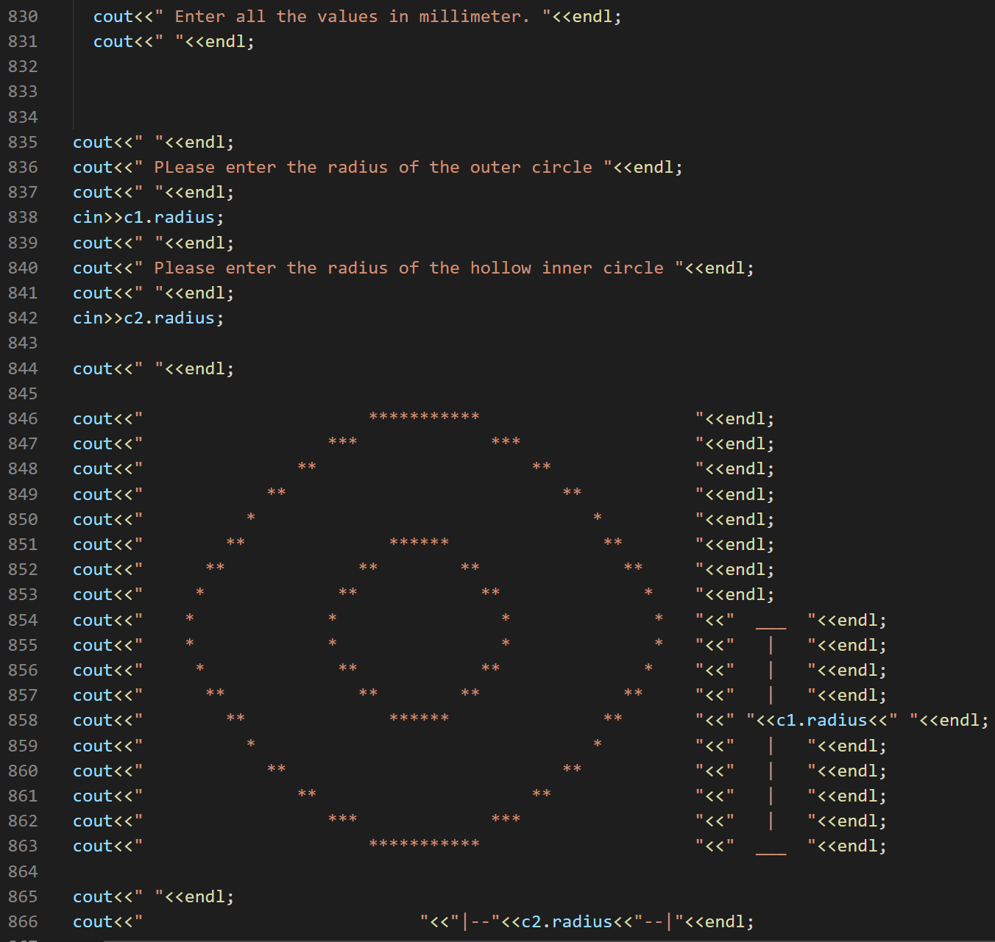

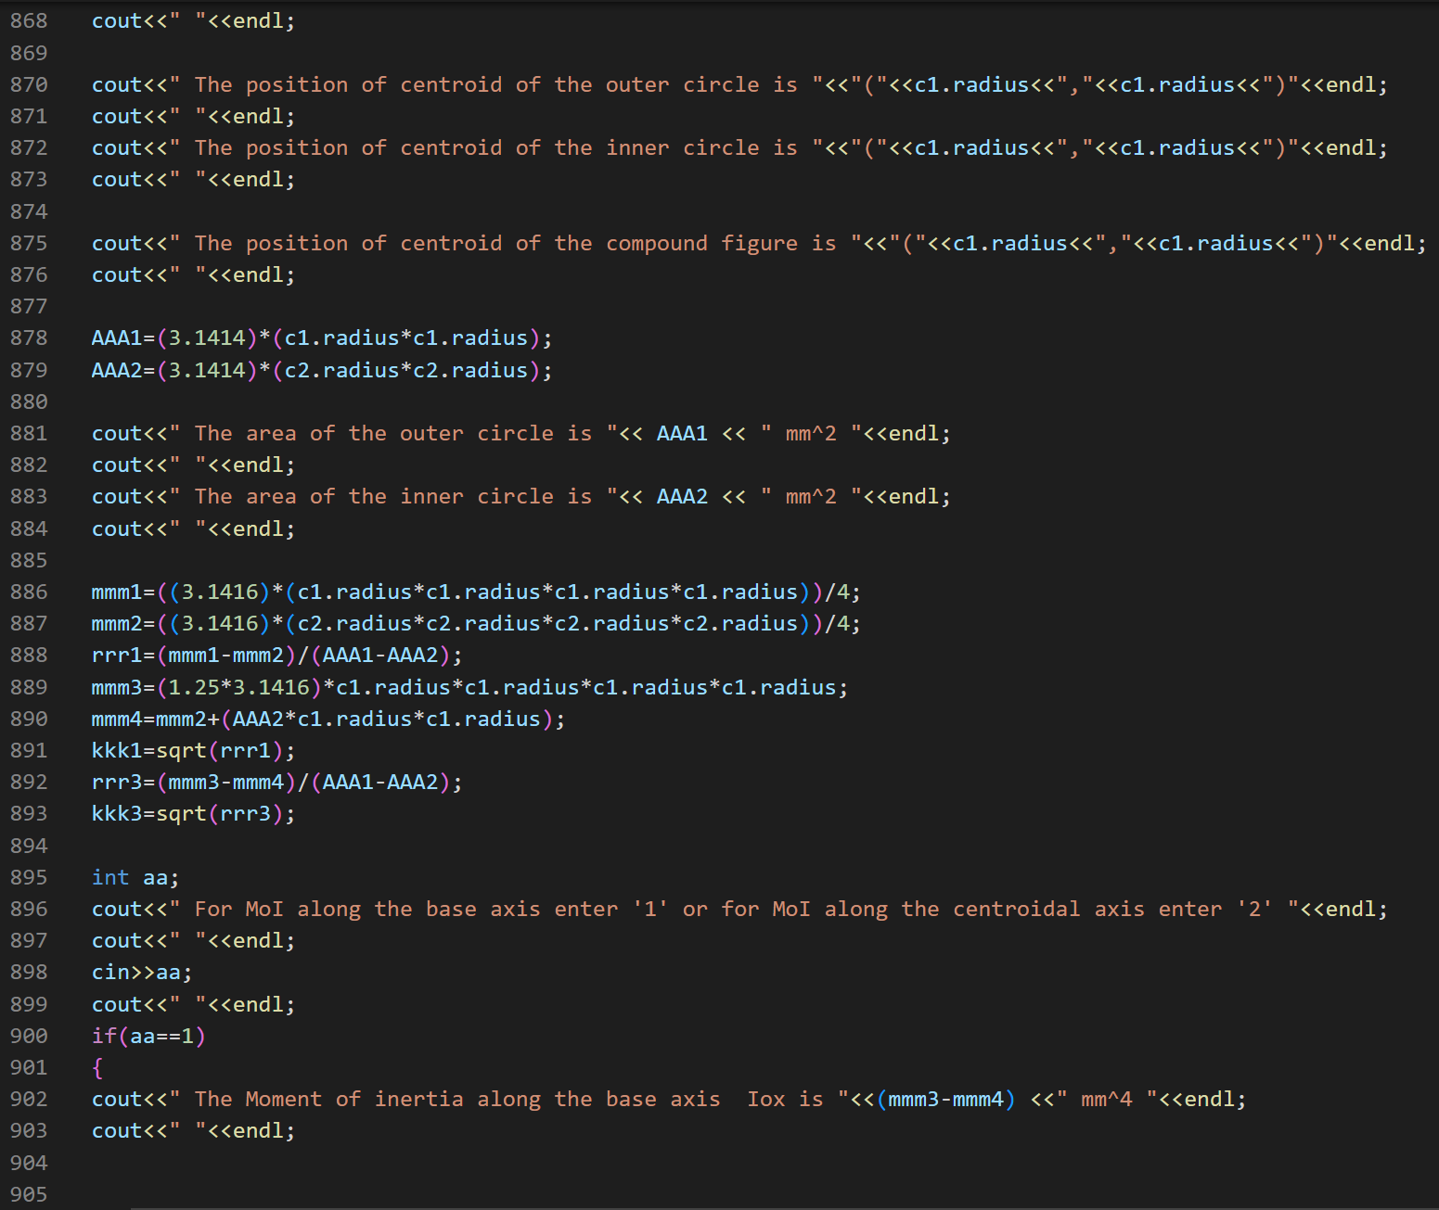

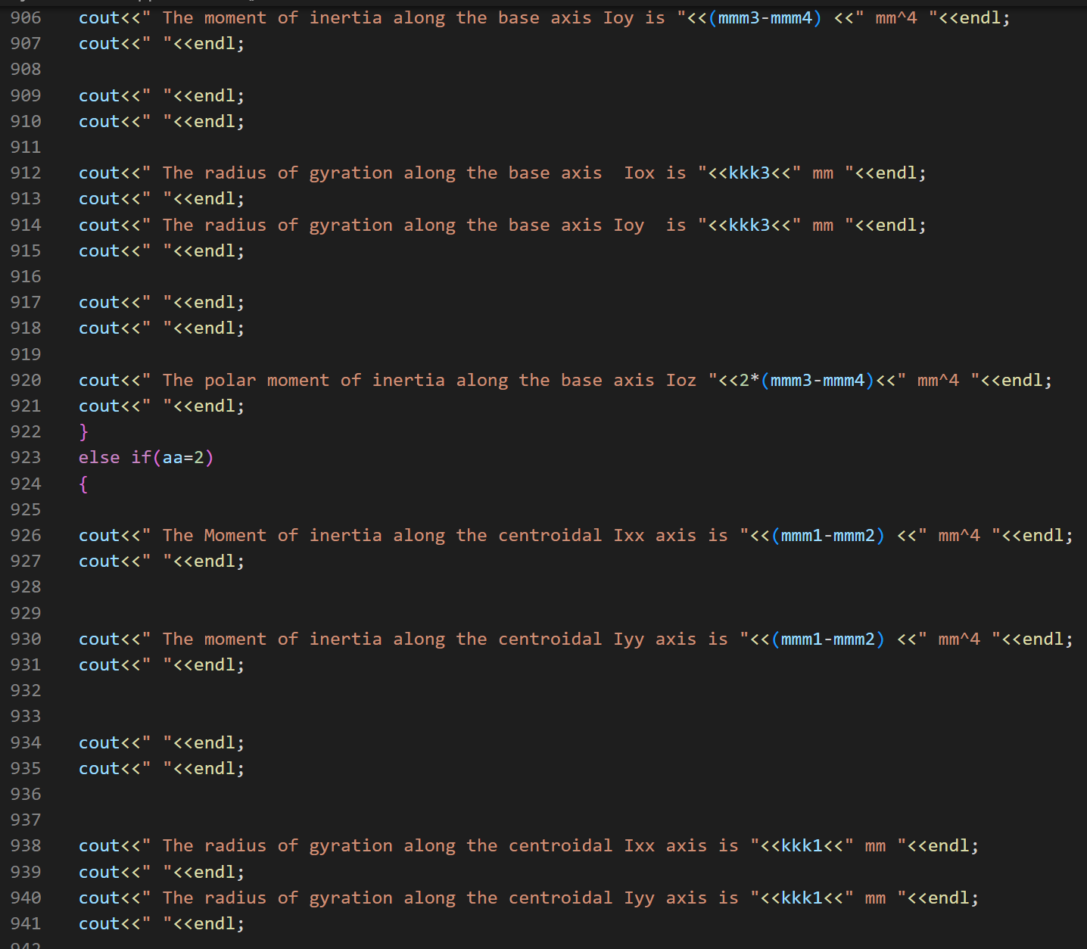

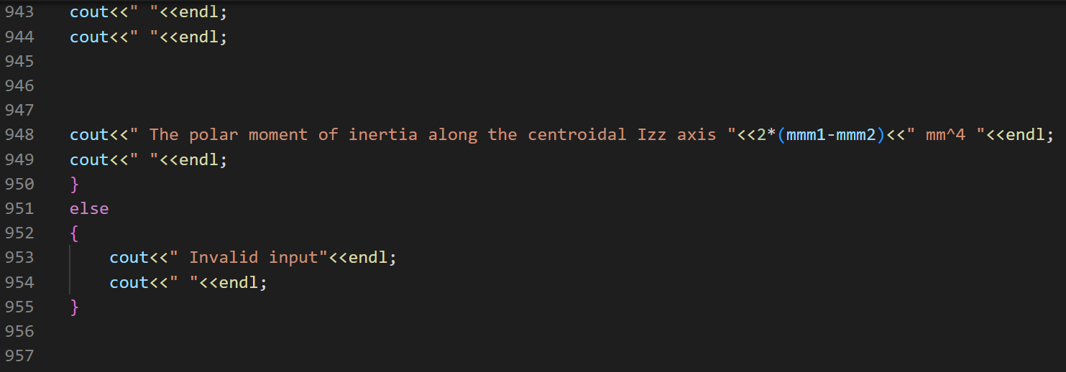

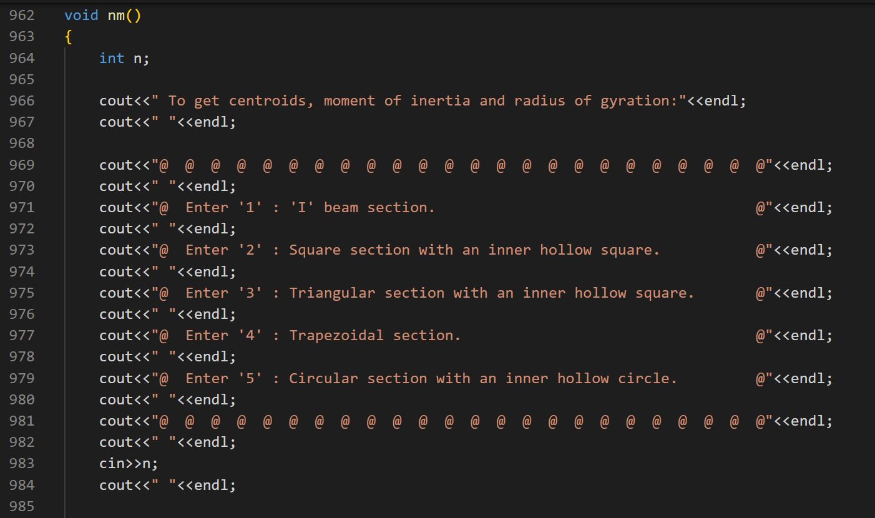

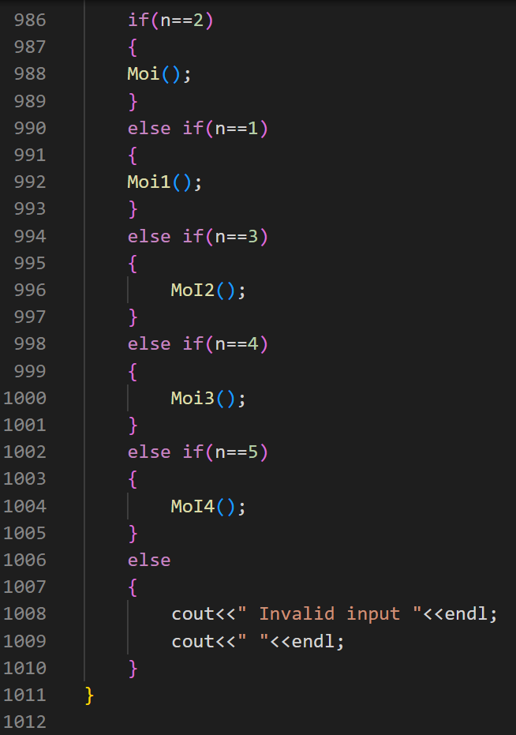

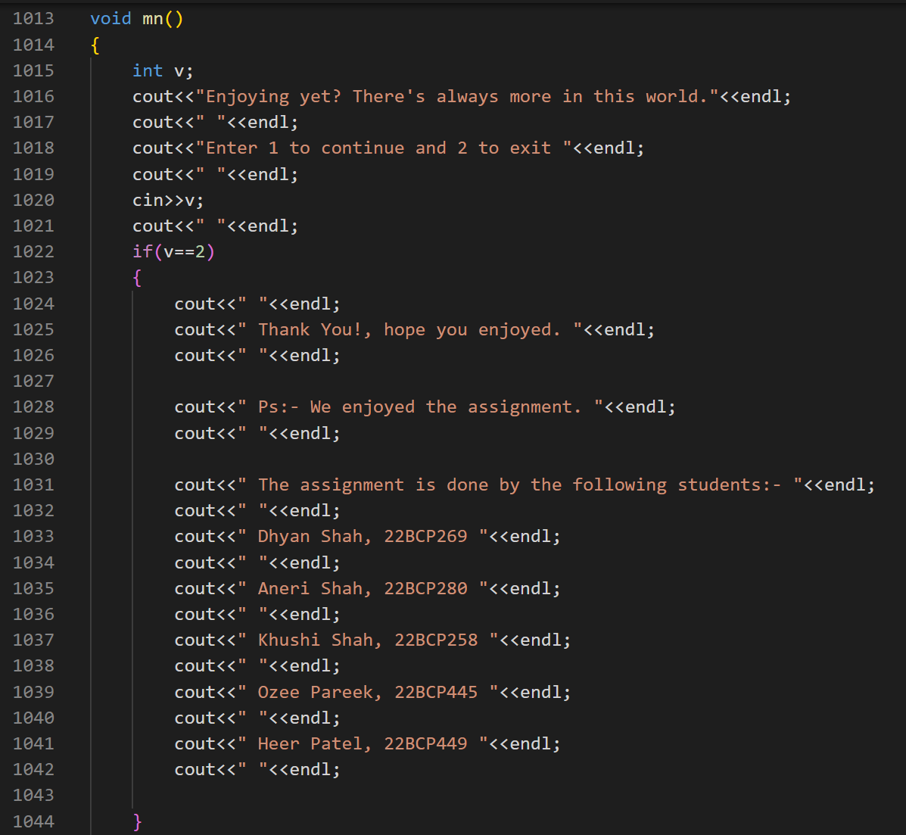

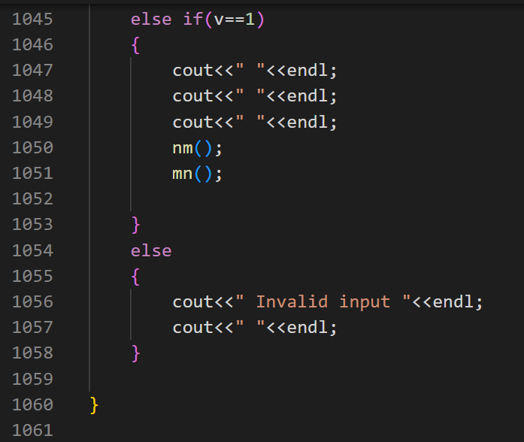

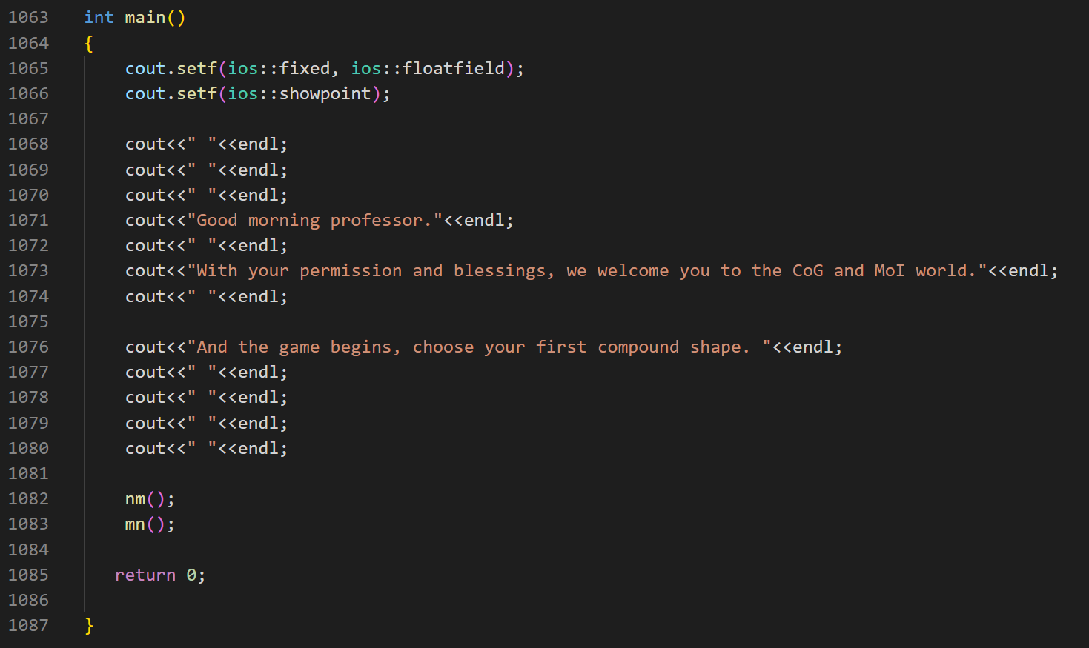

* **Future scope**

1) Input can be taken in any measuring unit (mm, cm, m).

2) Measurements without restriction of a range.

3) Unsymmetric and non-uniform shapes can be included.

4) Calculation via shifted axis can be included.

* **BIBLIOGRAPHY**

<https://www.w3schools.com/cpp/cpp_intro.asp>

<https://www.geeksforgeeks.org>

<https://byjus.com/jee/moment-of-inertia/>

<https://stackoverflow.com/>

<https://www.calcresource.com/moment-of-inertia-doubletee.html>